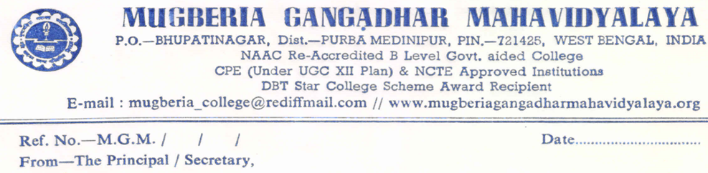
Report
on
“Workshop on Design Thinking, Critical Thinking & Innovation Design”
Dated: 31.03.2023
Organized by
IIC AND DEPARTMENT OF MATHEMATICS
Department of Mathematics in association with the Institution’s Innovation
Council of Mugberia Gangadhar Mahavidyalaya
Venue: - Mugberia Gangadhar Mahavidyalaya (SN Boos Hall)
Attended: - Mugberia Gangadhar Mahavidyalaya (Student’s)
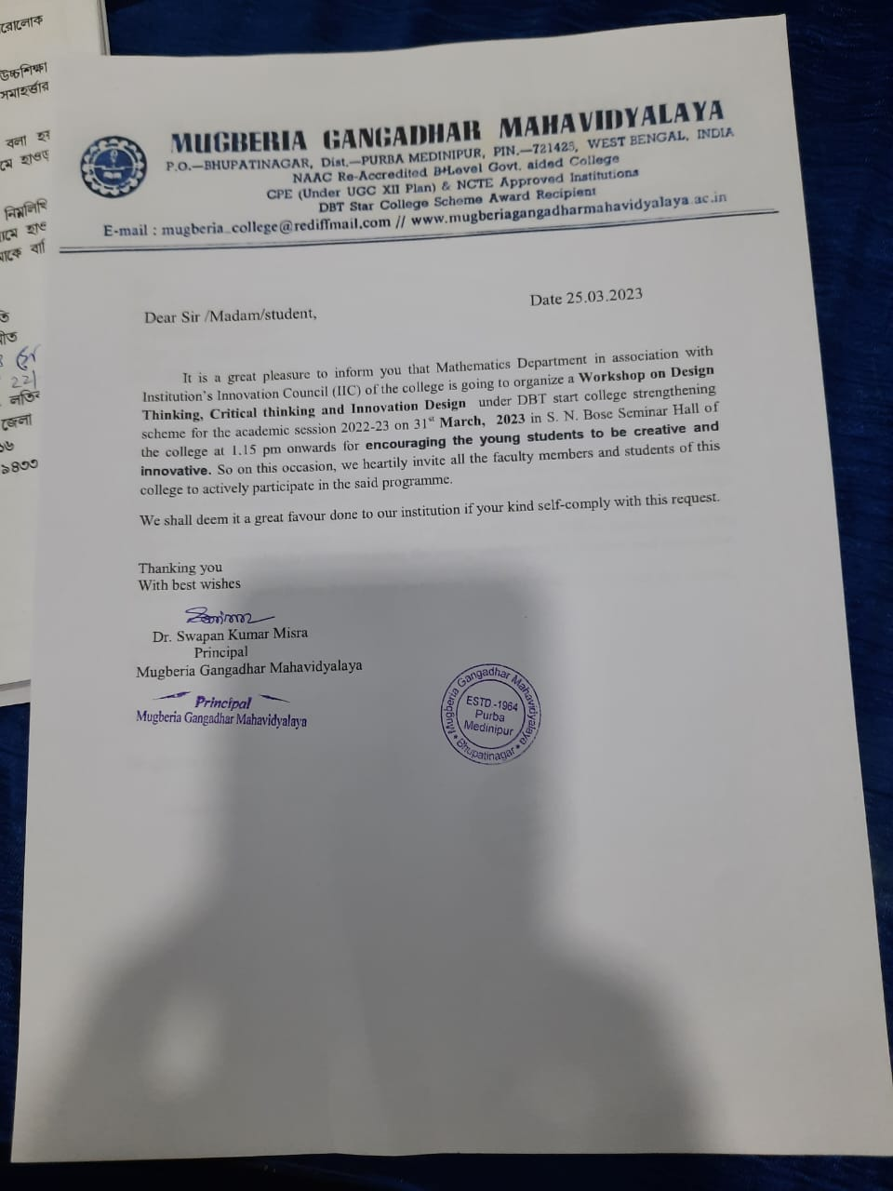
Day : 31.03.2023 (Friday) 01:15 am to 03:15pm
Time Speaker Topic Place
01:15pm – 01:30 pm | Dr. Swapan Kumar Misra, Principal, Mugberia Gangadhar Mahavidyalaya | Inaugural Speech | SN Boos Hall
01:30pm–01:45 pm | Dr. Kalipada Maity, Associate Professor, Head, Department of Mathematics | Well come Speech | SN Boss Hall
01:45pm-02:00pm | Dr.Bidhan Chandra Samanta, Associate Professor, Head, Department of Chemestry |  | SN Boss Hall
2:00 pm – 02:15 pm | Dr.Prasenjit
2:15 pm – 03:15 pm | Dr. Goutam Panigrahi,National Institute of Technology Durgapur  (Institute of National Importance Under  Government of India) | Design Thinking,  Critical Thinking & Innovation  Design | SN Boss Hall
66 Teacher’s & Student’s ( Teacher -9,Male -30 and Female-27)

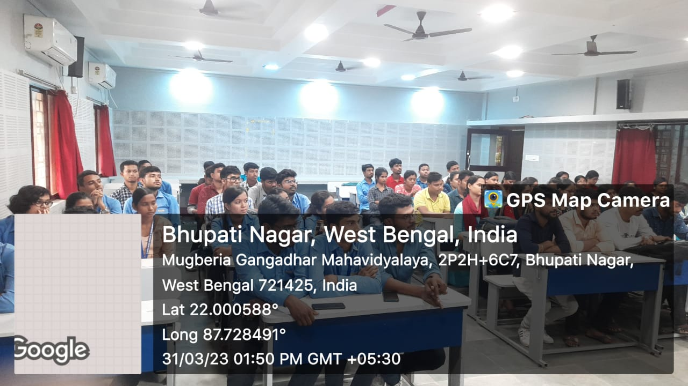 | 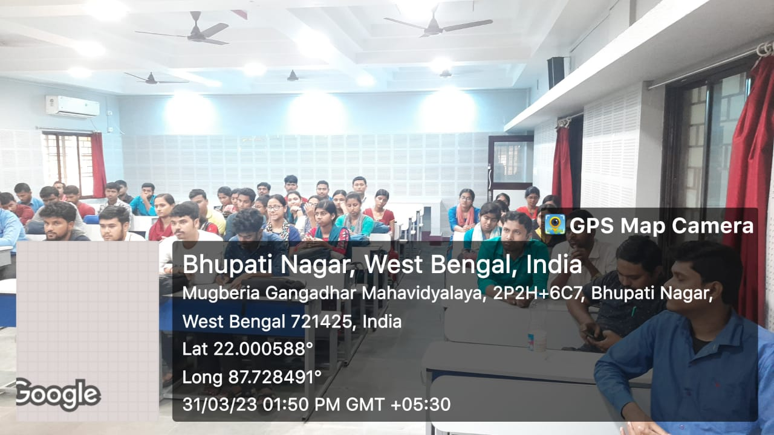
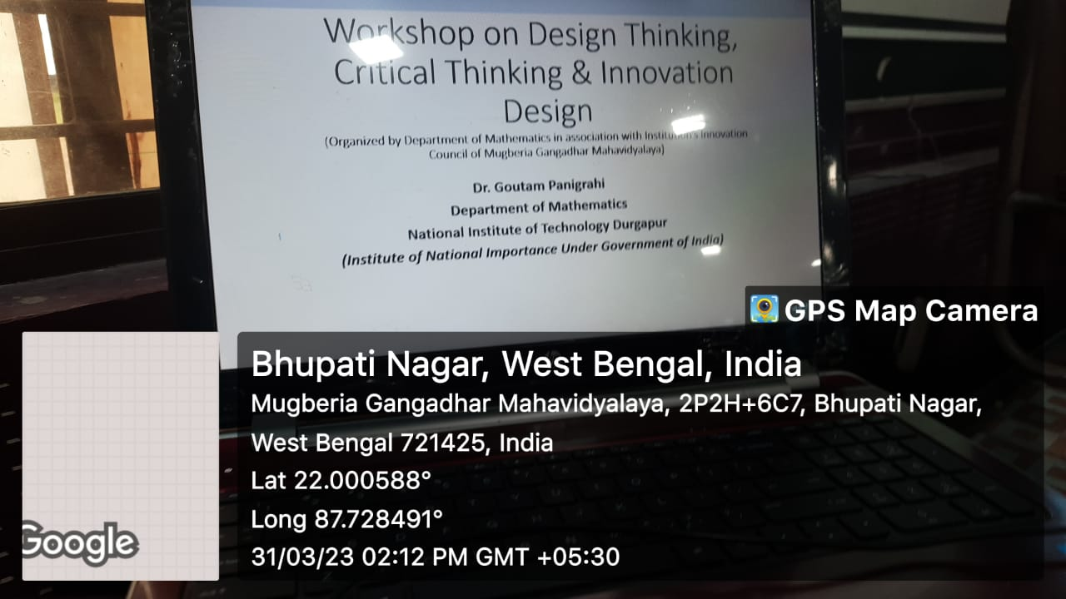 | 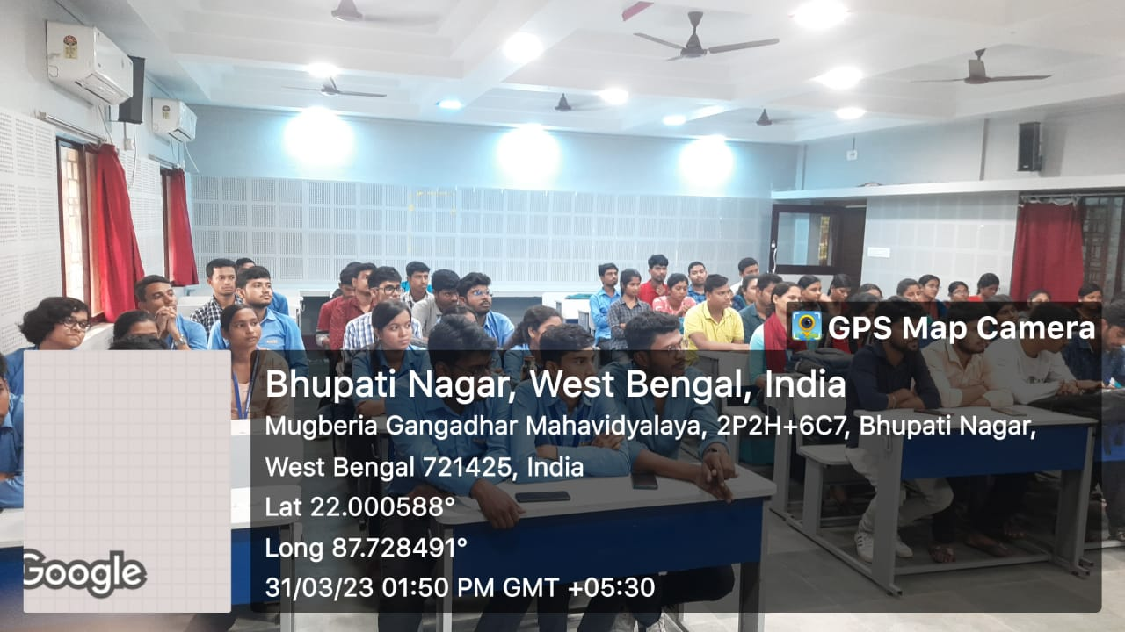

“Workshop on Design Thinking,
Critical Thinking & Innovation Design”
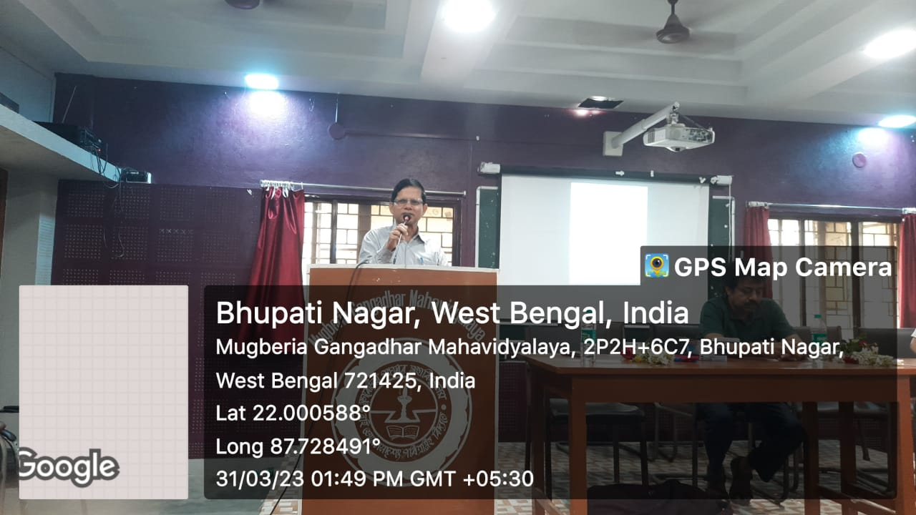 | 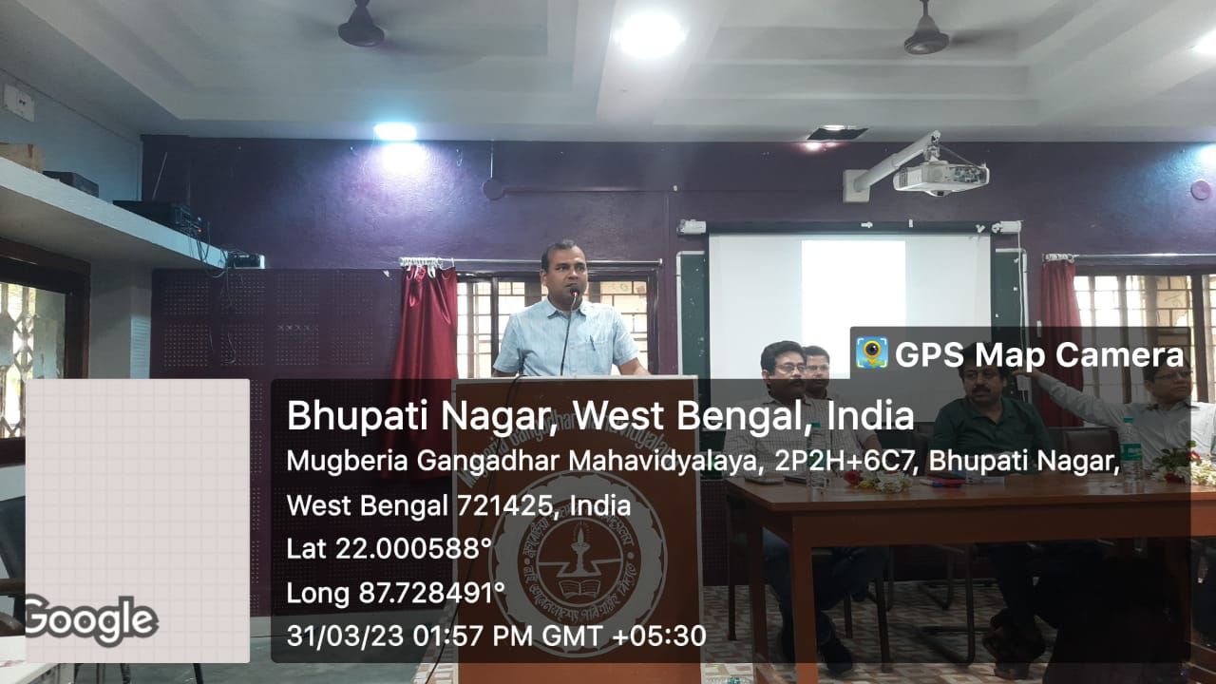
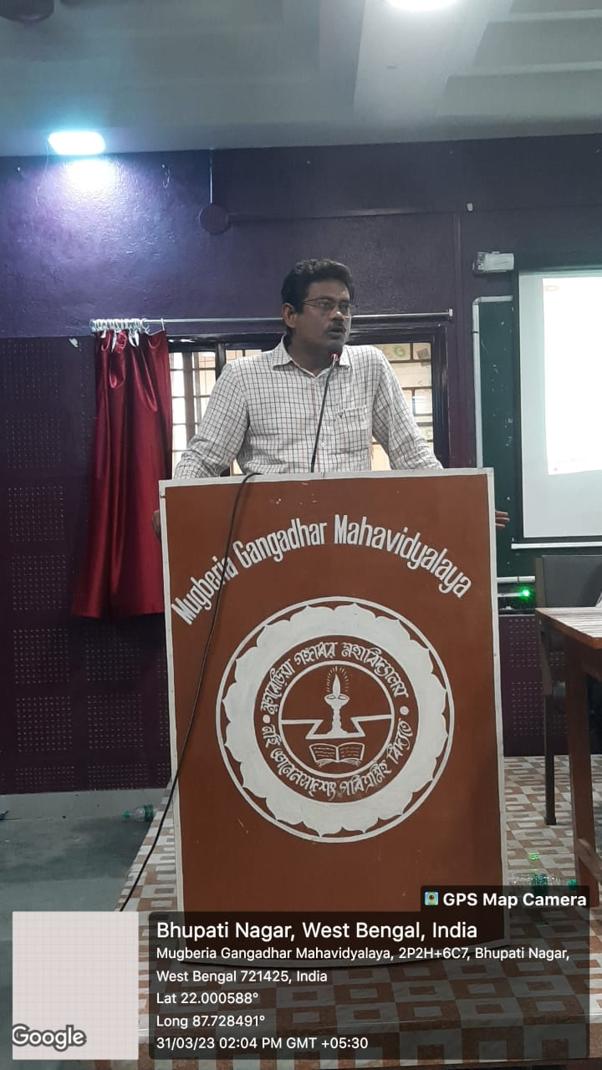 | 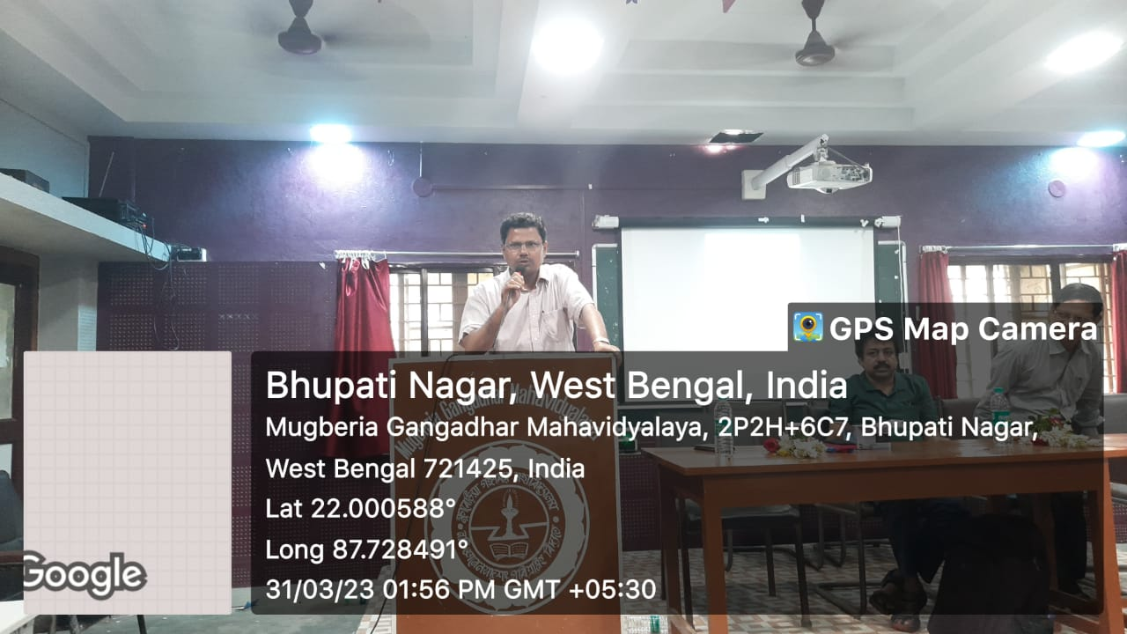
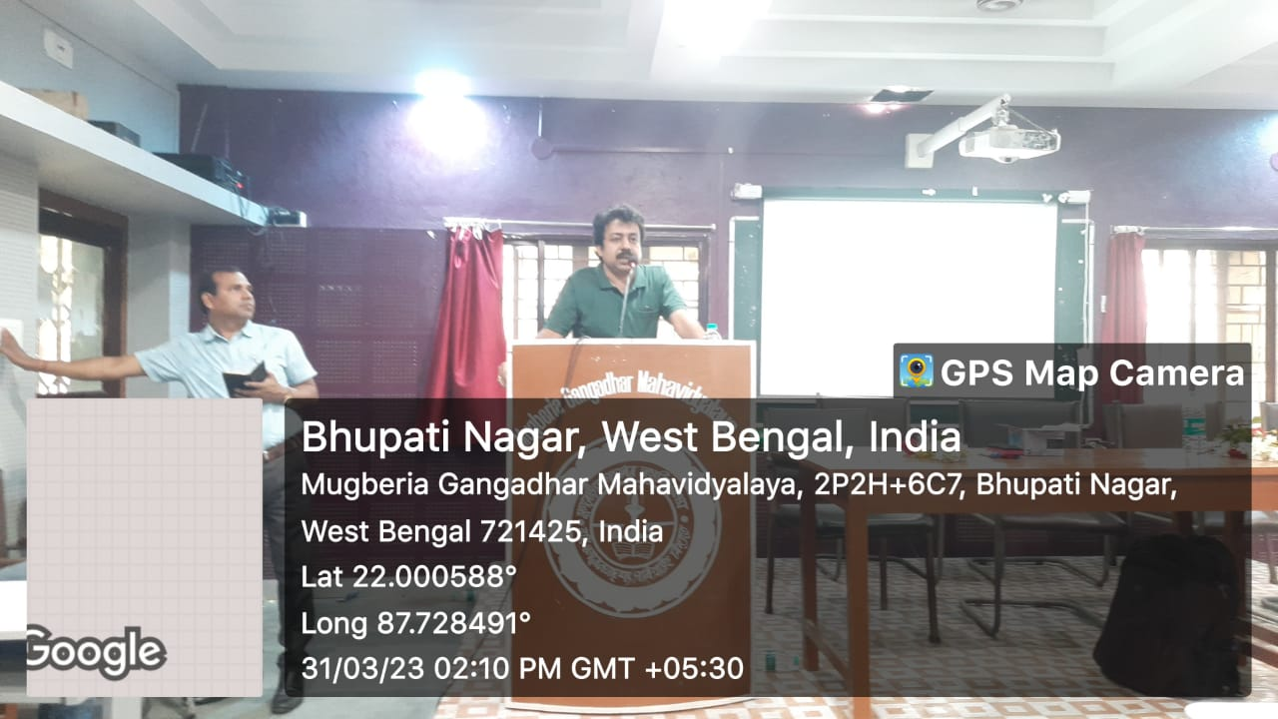

List of Students SIGNATURE:
