Three Days International Webinar
On
“Mathematical Modelling In The Context Of Covid-19”

on 30th, 31st August and 1st September, 2020
Under DBT STAR COLLEGE Strengthening Scheme (Govt. of India)

Organised by
Department of Mathematics (UG & PG)
Mugberia Gangadhar Mahavidyalaya
Bhupatinagar, Purba Medinipur – 721425

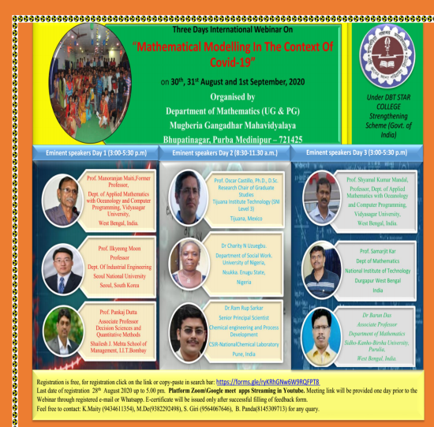  Three Days International Webinar | 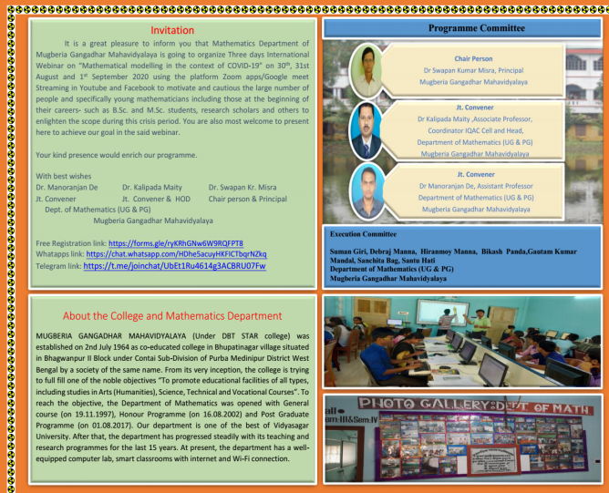
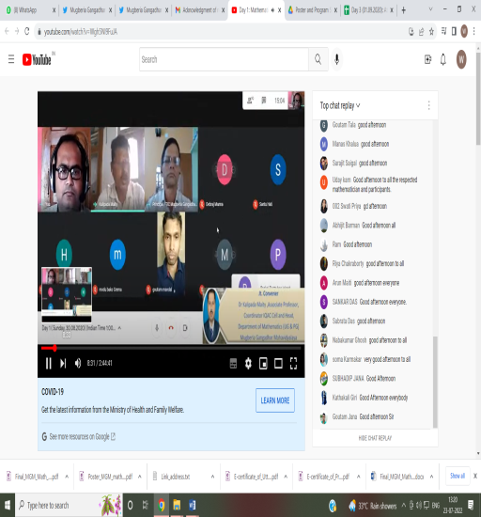 | 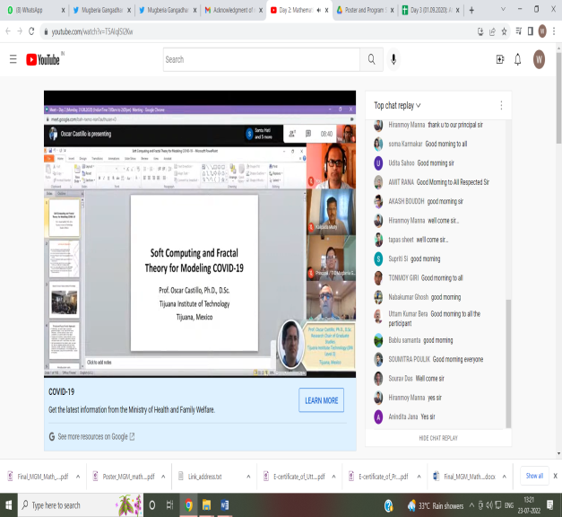

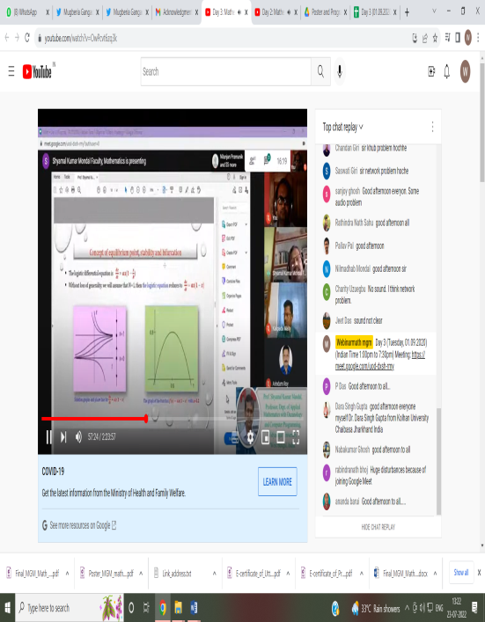 | 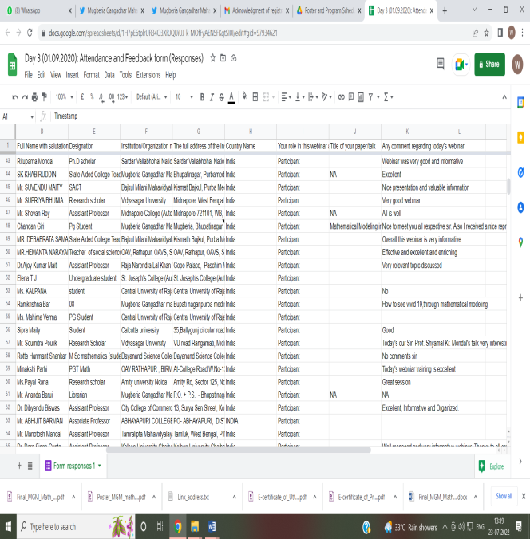
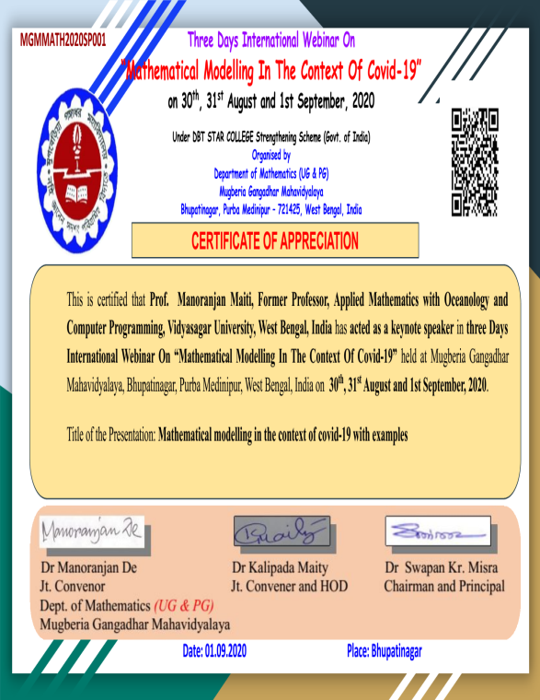 | 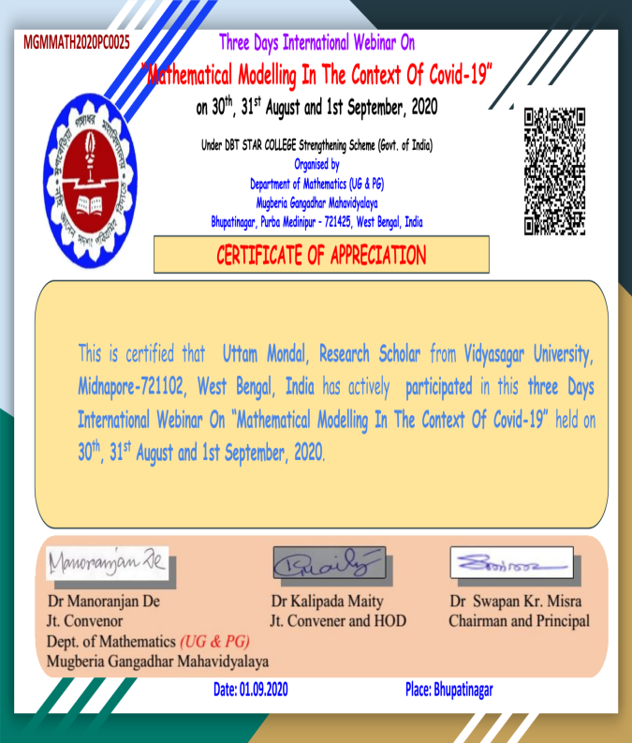

2. UGC Sponsored National Seminar on “Recent Trend in Bio-Mathematical Modeling under Uncertain Environment” organized by Mathematics Dept. 2015

