**Green Audit Report (2024-25)**

**of**

**MUGBERIA GANGADHAR MAHAVIDYALAYAYA**

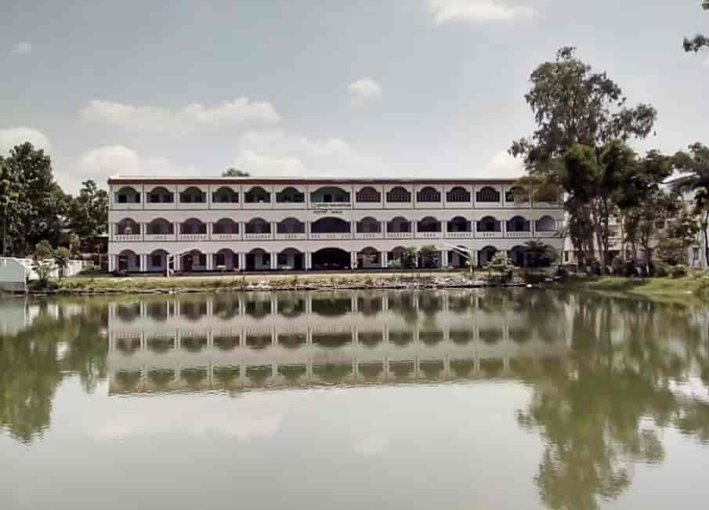

Dist :[Vill : Bhupatinagar , P.O : Bhupatinagar, Dist : Purba Medinipur, Pin : 721425](https://www.mugberiagangadharmahavidyalaya.ac.in/)

Email : [mugberia_college@rediffmail.com](https://www.mugberiagangadharmahavidyalaya.ac.in/about.php)

**Contents:**

|  |  |  |
| --- | --- | --- |
| **Sl No** | **Subjects** | **Page Number** |
| 1 | Introduction | 4 |
| 2 | Green Audit Working Team (2024-25) | 4 |
| 3 | Need for Green Audit | 1-5 |
| 4 | Methodology for Green Audit | 5-6 |
| On-site Visit | 6 |
| Focus Group Discussion | 6 |
| Energy and waste management Survey | 6 |
| 5 | Target Areas of Green Auditing | 7 |
| Energy Consumption | 7 |
| Heating, Ventilation, and Air Conditioning (HVAC) | 7 |
| Energy Awareness | 7-9 |
| Waste Management | 9, 10 |
| Composting | 10 |
| Water Usage | 11-12 |
| Water management table | 12 |
| Tabular data detailing the subject at hand | 12-13 |
| 6 | Transportation | 13-14 |
| Public Transport | 13-14 |
| Electric Vehicles | 13-14 |
| 7 | Overall Environmental Awareness | 14-16 |
| Curriculum Integration | 14-15 |
| Student Engagement | 17 |
| 8 | Green Campus | 17 |
| Flora Diversity | 17-20 |
| Faunal Diversity | 20-24 |
| 9 | Plantation of Wild type Medicinal plants | 24-26 |
| List of Floral groups | 26-28 |
| 10 | Conclusion | 36 |

**Certificated ISO Orginazation**

**1. Introduction:**

The results and conclusions and suggestions from a thorough green audit carried out at MUGBERIA GANGADHAR MAHAVIDYALAYAYA are presented in the report that continues. The audit's goals were to evaluate theCollege's environmental impact and spot areas where sustainability may be improved. The audit addressed topics like journeys, disposal of trash, water use, electricity consumption, and general environmental awareness.

**Green Audit Working Team (2024-25)**:

|  |  |  |
| --- | --- | --- |
| **Sl No** | **Name of the Members** | **Designation** |
| **1** | **Dr Swapan Kumar Misra** | **Principal-Cum-Secretary** |
| **2** | **Smt. Irani Banerjee Chatterjee** | **Assistant Professo,** |
| **3** | **Dr. Prasenjit Ghosh** | **Teachers' Representative** |
| **4** | **Dr Bidhan Chandra Samanta** | **Teachers' Representative** |
| **5** | **Dr Kalipada Maity** | **Teachers' Representative** |
| **6** | **Irani Banerji Chattterjee** | **Teachers' Representative** |

**2. Need for Green Audit:**

Green audits, also known as environmental audits or sustainability audits, are becoming more and more necessary in today's society for several reasons:

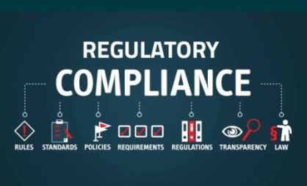**(a) Environmental Impact:** Green audits assist in evaluating and reducing an organization's negative environmental impact. They assess variables like energy use, waste production, water use, and emissions, identifying areas that might be improved to lessen environmental harm.

**(b) Regulatory Compliance:** Businesses must abide by the environmental laws and standards that have been set in many nations. Green audits assist businesses in complying with regulations and avoiding fines or other legal repercussions for non-compliance.

**(c) Cost Reduction:** Green audits can reveal inefficiencies and wasteful behaviours within a institutions, opening up chances for cost savings. Institutions can apply methods to save operational costs and boost overall efficiency by analyzing energy usage, resource consumption, and waste management.

**(d) Reputation and Stakeholder Expectations:** Institutions and other stakeholders now demand more environmentally conscious company practices. Green audits offer organization transparency and prove its dedication to sustainability, strengthening its reputation and fostering trust among clients, staff, investors, and communities.

**(e) Risk Management:** Environmental hazards can have serious financial and reputational ramifications for firms, including pollution events, regulatory non-compliance, and supply chain interruptions. By evaluating environmental management systems, ensuring sufficient controls are in place, and putting preventative measures in place to deal with possible problems, green audits assist in identifying and mitigating these risks.

**(f) Continuous Improvement:** Green audits encourage a continuing commitment to sustainability rather than being one-time events. Organizations can see trends, set goals, and implement improvement initiatives by routinely evaluating and tracking environmental performance. This iterative process promotes a culture of sustainability and propels long-lasting transformation.

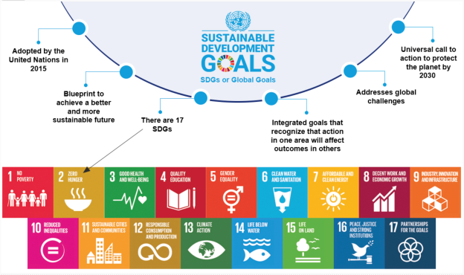**(g) Sustainable Development Goals (SDGs):** An international framework for solving urgent environmental and social issues is provided by the Sustainable Development Goals. Organizations can better align their operations with these objectives with the aid of green audits, paving the way for a more just and sustainable future. To evaluate, enhance, and confirm environmental performance, green audits are essential. They allow companies to control risks, comply with rules, cut costs, improve reputations, and support sustainable development.

**3. Methodology for Green Audit:**

Audits of an organization's environmental performance and practices are known as "green," "environmental," or "sustainability" audits. They entail assessing the company's influence on the environment, resource usage, waste management, and adherence to environmental legislation. Here is a procedure for carrying out a green audit:

(a) Planning:

(b) Identify audit team and resources:

(c) Develop an audit plan: Create a detailed plan outlining audit activities, timelines, responsibilities, and communication channels.

(d) Data Collection:

(e) Gather information:

(f) Conduct site visits and interviews:

(g) Review documentation:

(h) Evaluation and Analysis:

(i) Assess environmental impacts:

(j) Evaluate compliance:

(k) Identify strengths and weaknesses:

(l) Quantify results:

(m) Reporting:

(n) Prepare an audit report:

(o) Communicate results:

(p) Follow-up and Improvement:

(q) Develop an action plan:

(r) Monitor progress:

(s) Continuous improvement:

The methodology adopted to conduct the Green Audit of the Institution had the following components.

**3.1. On-siteVisit :**

The Green Audit Team carried out the five-day field trip. The tour's main goal was to evaluate the Institution's waste management procedures, energy conservation tactics, and other aspects of its green cover. The protocols for sample collection, preservation, and analysis were followed scientifically.

**3.2. Focus Group Discussion :**

The nature club, staff, and management members participated in focus group discussions on various facets of the green audit. Identification of attitudes and awareness towards environmental issues at the institutional and local levels was the main topic of discussion.

**3.3. Energy and waste management Survey:**

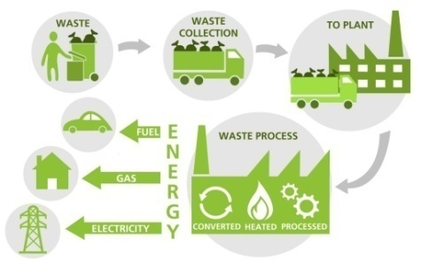 The audit team evaluated the College's waste generation, disposal, and treatment facilities as well as its energy usage pattern with the assistance of teachers and students. A comprehensive questionnaire survey method was used to carry out the monitoring.

**4. Target Areas of Green Auditing:**

**Green Energy :**

Solar energy is a clean, renewable energy source that doesn't create carbon emissions or other greenhouse gases . Solar energy can improve air quality, reduce water use, and provide ecosystem services.

A process for resource management includes a green audit. The actual usefulness of green audits lies in the fact that they are conducted at predetermined intervals and that the results might show improvement or change over time, even though they are individual events. The concept of an eco-campus primarily emphasizes the effective use of energy and water, the reduction of waste output or pollution, and economic efficiency.

These indications are evaluated during the "Green Auditing of this Educational Institute" procedure. In order to reduce emissions, obtain a reliable and affordable energy supply, promote personal responsibility, encourage and improve energy conservation, reduce the institute's energy and water use, reduce waste going to landfills, and incorporate environmental considerations into all contracts and services deemed to have significant environmental impacts, Eco-campus focuses on these goals. Water, energy, trash, and green campus are the focus topics for this green audit.

**4.1. Energy Consumption:**

**4.1.1. Lighting:**The audit showed that many of theCollege's lighting fixtures were ineffective and outdated. It is advised to use natural light whenever possible, add occupancy sensors, and swap out conventional light bulbs for energy-efficient LED ones.

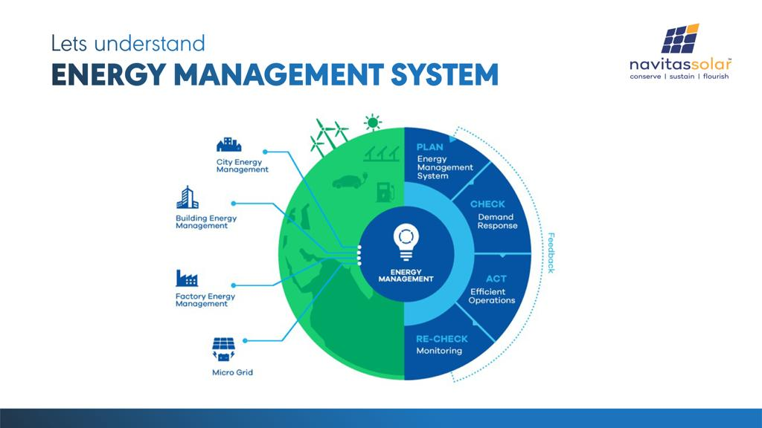**4.1.2. Heating, Ventilation, and Air Conditioning (HVAC):**

The HVAC systems were discovered to be working less efficiently than necessary. Energy usage can be considerably decreased by switching to energy-efficient HVAC equipment, using programmable thermostats, and performing routine maintenance.

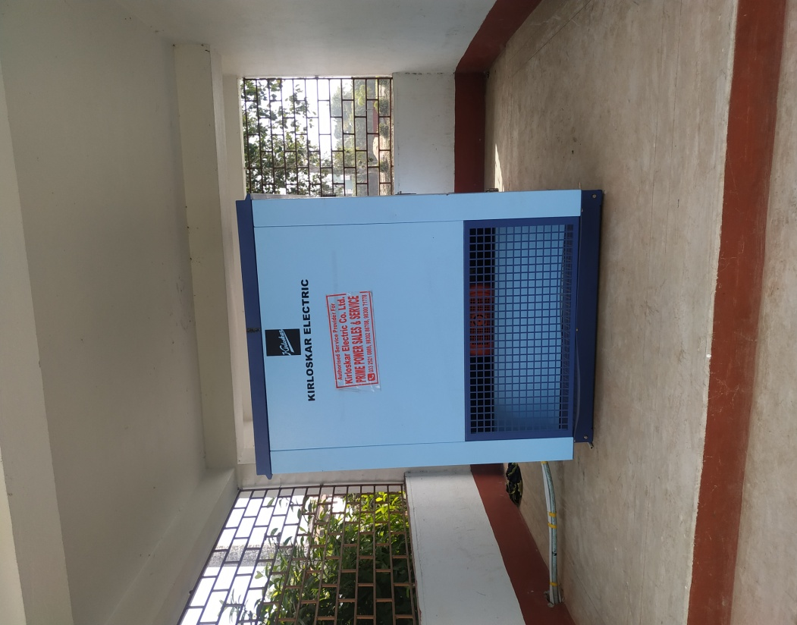

**4.1.3. Energy Awareness:**

The college should promote energy conservation practices among employees and students. Campaigns, educational activities, and financial incentives for energy-saving projects can all help achieve this.

|  |  |
| --- | --- |
| E:\Backup F\Personal\College Audit\Mugberia Gangadhar Mahavidyalaya\WhatsApp Image 2025-01-08 at 9.05.57 AM.jpg | E:\Backup F\Personal\College Audit\Mugberia Gangadhar Mahavidyalaya\WhatsApp Image 2025-01-08 at 9.05.59 AM.jpg |
| **LED Bulb & save energy** | **Performing routine maintenance on electrical fans. The accumulation of dust and debris can hinder the fan's performance. Regular cleaning of the grilles, blades, and motor housing is necessary to maintain optimal operation, ensure smooth airflow& save energy.** |

**4.2. Waste Management:**

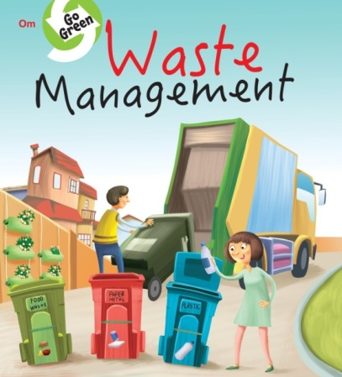

**4.2.1. Recycling:** Although there were recycling containers all across the campus, the audit showed that there was a lack of effective separation and information about recyclable products. Increased recycling rates can be achieved by upgrading signage, giving clear instructions and implementing a comprehensive recycling education programme.

**4.2.2. Composting:** The institution can set up a composting system to handle the organic waste produced by Hostel members (Boys & Girls Hostel). Composting can help drastically reduce the quantity of garbage dumped in landfills while also producing beneficial compost for campus landscaping and gardening.

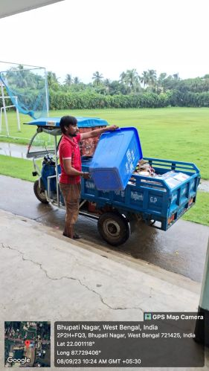 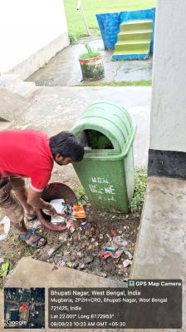 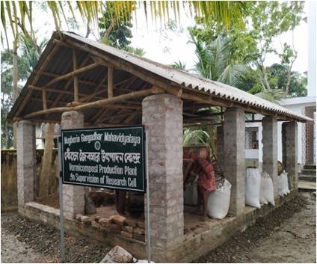

**Table: Different types of waste generated in the College and their disposal**

|  |  |  |
| --- | --- | --- |
| Types of waste | Particulars | Disposal method |
| E-Waste | Computers, electrical and electronic parts | Store these in a separate tank, and sell them directly after a certain amount of time. |
| Plastic waste | Pen, Refill, Plastic water bottles and other plastic containers, wrappers etc | Encourage people to use water bottles and other containers to be reused. Establish distinct recycling containers for plastic garbage, and after a predetermined period of time, we begin selling the collected recyclables directly. |
| Solid wastes | Paper waste, Damaged furniture, paper plates, food wastes | College campus allowing for the conversion of discarded food into nutrient-dense compost that may be used in the campus landscaping or in community gardens. Another option is for institutions to form partnerships with farmers in the surrounding area to collect food waste. |
| Chemical wastes | Laboratory waste | Water used to neutralise. When dealing with hazardous garbage, adhere strictly to all safety regulations. |
| Wastewater | Washing, urinals, bathrooms | Soak pits |
| Glass waste | Broken glass wares from the labs | Glass debris kept separate from other recyclable materials and disposed of in containers that are specifically intended for glass recycling. recycle glass in the correct manner by coordinating with the local recycling centers. |
| Sanitary Napkin | - | Napkin Incinerators |

**4.3. Water Usage:**

**4.3.1. Water Fixtures:** Water resources can be saved by swapping these fixtures for low-flow models and encouraging staff and students to practice water-saving habits.

**Water management table:**

|  |  |  |
| --- | --- | --- |
| **Water Management Tasks** | **Frequency** | **Responsible Party** |
| Routine examination of water supplies | Monthly | Green Audit Working Team |
| Testing for drinking water quality | Half-yearly | Do |
| Awareness of water conservation | Half-yearly | Green Audit Working Team & various department |
| Infrastructure for water distribution that needs upkeep and repair | As needed | Caretaker |
| Reporting and analysis of water use | Annually | Green Audit Working Team & Caretaker |
| Learn what causes excessive water consumption. | As needed | Caretaker |

**Tabular data detailing the subject at hand:**

|  |  |  |
| --- | --- | --- |
| **Sl No** | **Parameters** | **Response** |
| **1** | Source of water | Underground, Pond (2500 sqft)  **Note:**The ground's water serves as a drinking water supply for around 4,500 people, including students and staff members. |
| **2** | Source of Drinking Water | Ground's water |
| **3** | Any treatment for drinking water | Nil  **Note:** Water purifiers have been installed in 1-2 numbers on each floor and are maintained for 3–4 months afterward. |
| **4** | What is the total number of motors that are used? | 02 numbers |
| **5** | What is the total number of water tanks? Capacity of tank | 4 numbers@ 1000 liters each |
| **6** | Tap water | 120 numbers |
|  | Quantity of water pumped every day | 18000 liters/per day |
| **7** | Do you waste water, and if so, why? | No |
| **8** | How much water is required for gardening purposes? | 200 liters/per day |
| **9** | How many water coolers are there in total? | 00 |
| **10** | Do you have access to rainwater harvesting? | Yes |
| **11** | The number of units harvested and the total volume of water | 01 number, We have natural water pond in front of our College Campus, that is 2500 square feet and 4,000 liters of tanks in total to store Water. |
| **12** | Any leaky taps | None |
| **13** | Daily amount of water that is lost. | Not applicable |
| **14** | Is there any kind of plan for the management of water? | Raise public awareness regarding the importance of water conservation, the prevention of pollution, and the implementation of sustainable water management practices. Unambiguous water rights and equitable water allocation regulations should be established to ensure that water is distributed fairly among the many different users. |
| **15** | Have any methods for conserving water been implemented? | Rainwater Harvesting |

**4.4. Transportation:**

**4.4.1. Public Transport:** The college's carbon footprint can be significantly reduced by encouraging employees and students to use public transport. Sustainable transport solutions can be promoted by offering cheap bus passes, encouraging carpooling, and supporting bicycle infrastructure.

|  |  |  |  |
| --- | --- | --- | --- |
| E:\Backup F\Personal\College Audit\Mugberia Gangadhar Mahavidyalaya\Scan...jpg | **Students** | **Employee** | **Total** |
| Average numbers over 6 days in a peak session | | |
| **Bicycles are being used as modes of transportation for getting to and around theCollege by students, non-teaching staff and teaching staff.** | Girls- 1910  Boys-1201 | 168 | 3279 |

**4.4.2. Electric Vehicles:**To aid in the switch to electric transport, the college may choose to invest in infrastructure for charging EVs. Additionally, encouraging the use of electric vehicles through awareness programs and incentives can help lower the emissions produced by on-campus transportation.

**4.5. Overall Environmental Awareness:**

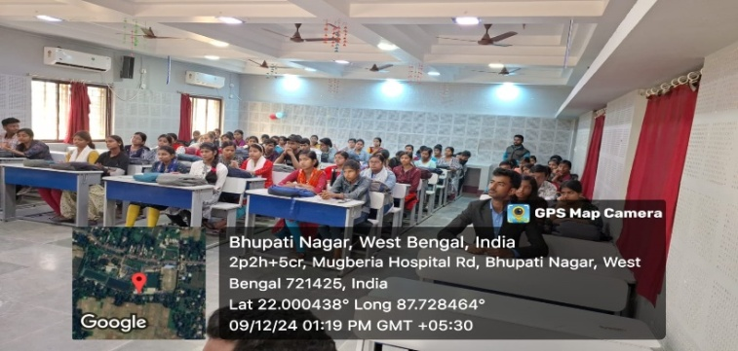**4.5.1. Curriculum Integration:**

The institution can integrate environmental awareness and sustainability into its curriculum across various subject areas. This strategy will guarantee that students receive instruction and training in environmental stewardship, encouraging sustainable thinking.

|  |  |  |
| --- | --- | --- |
| **Environmental awareness across different subjects** | **Parameters** | **Program time** |
| Language Arts | Discuss texts from literature that are in some way connected to topics concerning the environment, such as conservation or environmental advocacy. Compose poetry or essays that argue for the protection of the environment and use persuasion. Conduct research on a variety of environmental topics, then present your findings. Through various awareness programs, they understand the environmental laws and regulations that apply on the local, national, and international levels. Discuss the roles that governments, NGOs, and people play in the effort to solve environmental problems. Investigate the environmental concerns from both a historical and cultural point of view. | Whole year |
| Arts | Investigate the causes of climate change and possible solutions to the problem.Analyse the impact that human activities have had on different landscapes as well as the distribution of natural resources. Studies should be done on urbanization, logging, and industry's impact on the natural environment. Investigate geographical approaches to resolving environmental issues, such as environmentally responsible land management planning. | Whole year |
| Pure/ Social Science | Conduct studies on environmental issues, such as assessing water quality, soil analysis, power consumption or recycling.To better comprehend environmental patterns and forecasts, consider using mathematical models. Investigate the repercussions of environmental actions on the economy, such as doing cost-benefit analyses for environmentally friendly projects. | Half-yearly/ each program |
| Bio-Science | Study subjects include ecosystems, biodiversity, and the interconnectedness of all living things. | Whole year |
| Physical Education | Encourage students to develop an appreciation for the natural world by having them participate in outdoor sports and activities. Talk about the significance of physical activity for both one's own health and the health of the environment (for example, taking bike instead of the car). | Whole year |
| NSS | To enhance the amount of green cover and fight deforestation, organizing tree-planting events in local communities and educational institutions is important. To combat littering and to encourage a clean environment, it is important to organize routine clean-up efforts in public places like parks and beaches.To educate both students and members of the general public about environmental issues such as climate change, waste management, renewable energy, and conservation, workshops and seminars should be organized. It should be a priority to create opportunities for individuals to engage with the natural world and develop a sense of ownership over its preservation through participating in hikes and other outdoor activities. To raise awareness about environmental issues and motivate people to take action, you might use social media, posters, and booklets. | Whole year |

**4.5.2. Student Engagement:** A culture of sustainability can be promoted among students by supporting student-led projects, creating environmental groups, and holding awareness events and workshops.

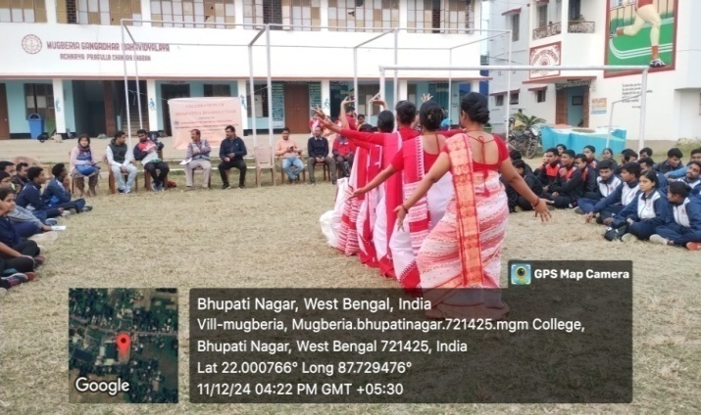 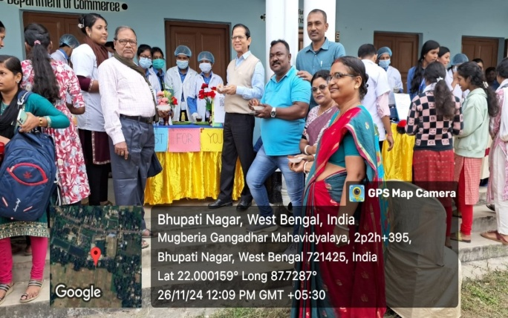

**5. Green Campus:**

**5.1.Floral Diversity:**

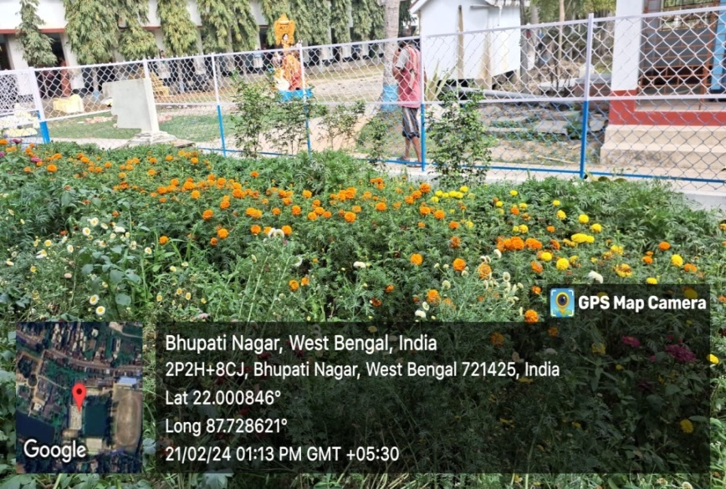The following are some actions to take into account when setting up a plantation programme at your college:

-Organise a group of academics, employees, and students who are interested in managing the plantation programme. Assign roles and duties to make the execution go smoothly.

-Consult with local forestry professionals or environmental groups to discover native or adapted tree species that are well-suited to the climate, soil, and goal of the plantation programme. Research and choose suitable tree species.

-To obtain the necessary approvals or permits for planting trees on campus or in the neighborhood, check with theCollege administration or other appropriate authorities.

- Look into possible funding options, including grants, sponsorships, or collaborations with nearby companies or environmental organizations. This will aid in defraying the price of buying trees, equipment, and other required supplies.

- Establish the plantation event's date, time, and venue. Plan the delivery of the trees, tools, and equipment to the planting location. Make sure that safety precautions are in place, including appropriate instruction on planting methods and equipment use.

-Promote the planting programme within the campus community by using various communication channels, such as posters, social media, emails, and word-of-mouth, in order to raise awareness and find volunteers. Encourage everyone to volunteer, including alumni, faculty, staff, and students.

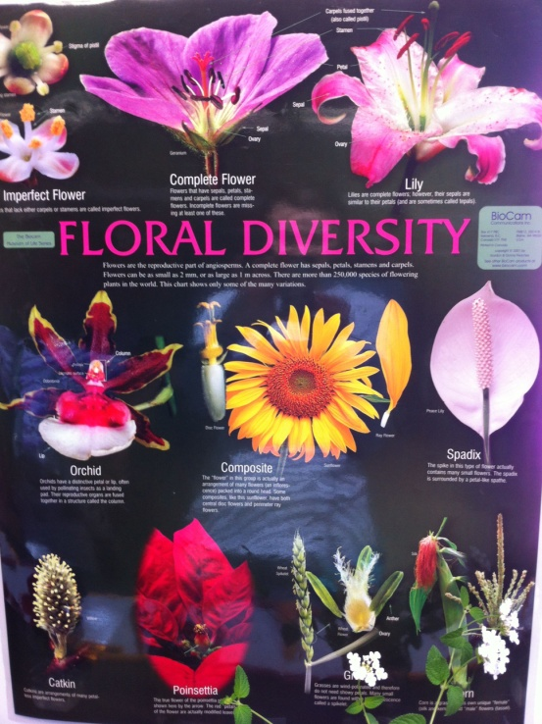

-Volunteers should be gathered at the planting site on the appointed planting day. Give them the equipment, instructions, and direction they need to plant trees correctly. Foster a sense of accomplishment and community pride while fostering teamwork.

-Stress the significance of taking care of the freshly planted trees. This could entail routine weeding, mulching, watering, and pest or disease inspection. To guarantee the long-term well-being and survival of the trees, think about setting up a system for volunteers or staff members.

-After the plantation programme, evaluate the impact and accomplishment of the effort. Keep an eye on the trees' growth and survival rate. To determine areas for improvement and to organize upcoming plantation programmes, collect participant and stakeholder input.

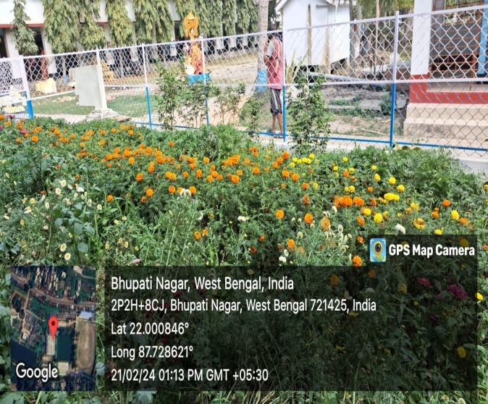 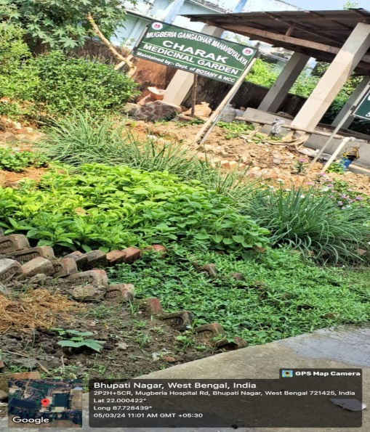

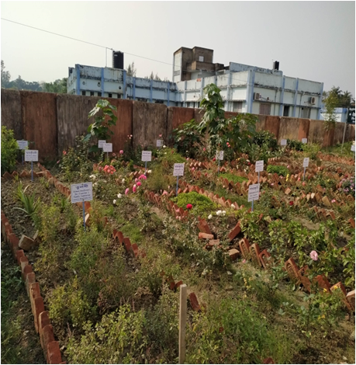

**Floral Diversity of the Campus**

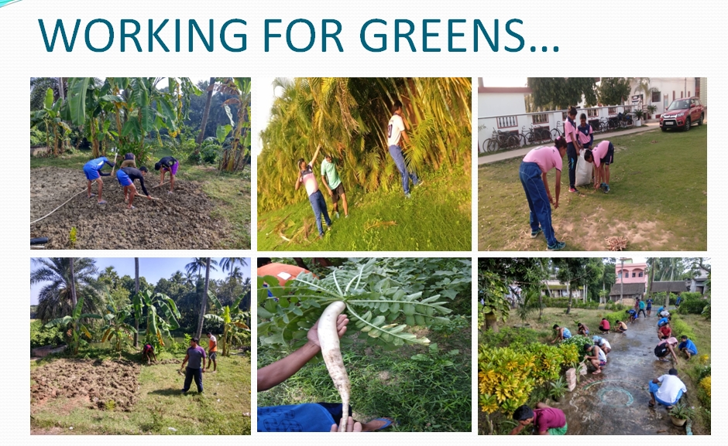

|  |
| --- |
| **Putting a number on the plants. Both the common and scientific names, as well as the family, are given for each plant.** |

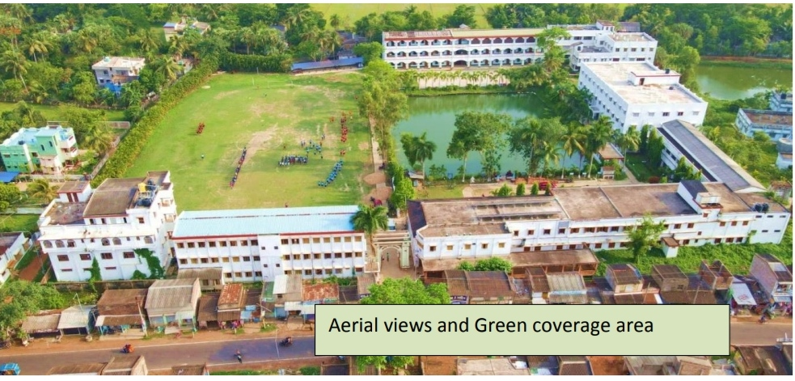

|  |
| --- |
| **The aesthetic attractiveness of the College campus is enhanced by a football field with lush grassland, which makes the institution more welcoming and appealing to students, professors and visitors.** |

**5.2. Faunal Diversity:**

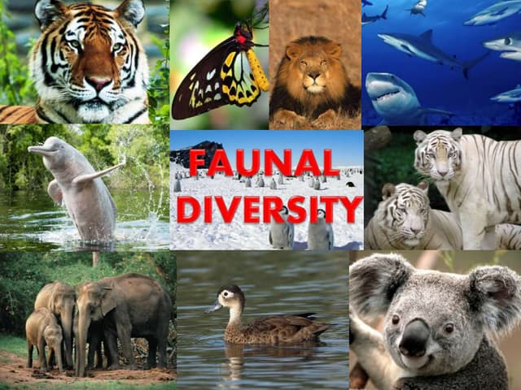Studying faunal diversity can increase awareness about environmental challenges and conservation's significance.Colleges that are home to a wide variety of animal species may be more likely to adopt environmentally friendly policies and methods of operation to safeguard the campus environment and the people who live there.

**Birds Diversity:**

A population of birds that is rich in variety is indicative of an ecosystem that is robust and thriving. Seed dispersal, the control of insect populations, and pollination are just a few of the many important functions that different species of birds perform to help maintain ecological equilibrium. They provide a contribution to the campus's general diversity of flora and fauna.

**6. Plantation of Wild type Medicinal plants:**

Two medicinal gardens were developed at our college premises. Many wild medicinal plant varieties were lost daily due to anthropogenic activities and pollution. After identifying these plants, we conserve these through propagation in our medicinal gardens. Any interested people or agencies can access it through the proper channel. Medicinal garden is a specific area inside the grounds of a College that is dedicated to the cultivation and upkeep of a wide range of different sorts of medicinal plants. As an educational and research resource, it makes it possible for students, faculty members, and researchers to investigate and gain knowledge on medicinal plants' varied qualities and applications. Culturing a medicinal garden on aCollege campus can confer major value and benefits to the surrounding academic community and society.

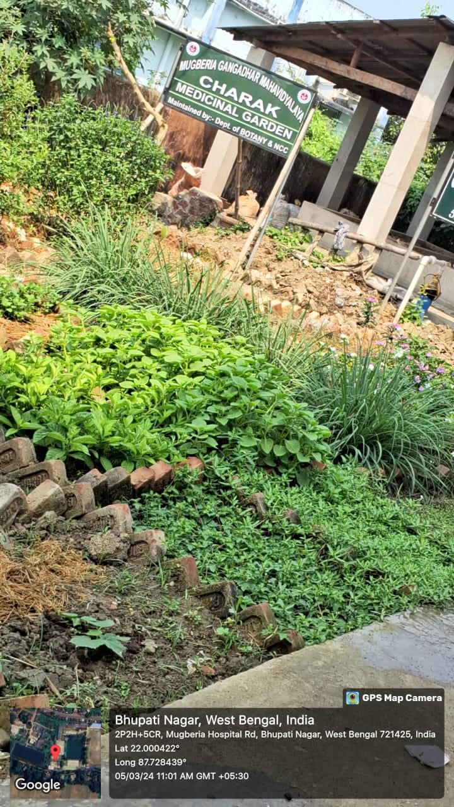

**Figure: Our medicinal garden (114 numbers of medicinal plants)**

**List of Floral groups:**

|  |  |  |  |  |
| --- | --- | --- | --- | --- |
| **Name of Plants** | | | | |
| **Sl** | **Scientific name** | **Common name** | **Family** | **No.of plant** |
|  | *Ficuselastica*[Roxb](https://en.wikipedia.org/wiki/William_Roxburgh). ex [Hornem.](https://en.wikipedia.org/wiki/Hornem.) | [Rubber tree](https://en.wikipedia.org/wiki/Rubber_tree). | [Moraceae](https://en.wikipedia.org/wiki/Moraceae) |  |
|  | *Delonixregia*  ([Boj.](https://en.wikipedia.org/wiki/Wenceslas_Bojer) ex [Hook.](https://en.wikipedia.org/wiki/William_Jackson_Hooker)) [Raf.](https://en.wikipedia.org/wiki/Constantine_Samuel_Rafinesque) | Gulmohor | [Fabaceae](https://en.wikipedia.org/wiki/Fabaceae) |  |
|  | Peltophorumpterocarpum  ([DC.](https://en.wikipedia.org/wiki/A._P._de_Candolle)) [K.Heyne](https://en.wikipedia.org/wiki/Karel_Heyne) | Radhachura | [Fabaceae](https://en.wikipedia.org/wiki/Fabaceae) |  |
|  | [*Casuarinaequisetifolia*](https://en.wikipedia.org/wiki/Casuarina_equisetifolia)L. | Jhau | [Casuarinaceae](https://en.wikipedia.org/wiki/Casuarinaceae) |  |
|  | *Lagerstroemia speciosa*  ([L.](https://en.wikipedia.org/wiki/Carl_Linnaeus)) [Pers.](https://en.wikipedia.org/wiki/Christian_Hendrik_Persoon) | Jarul | Lythraceae |  |
|  | *Samaneasaman*  ([Jacq.](https://en.wikipedia.org/wiki/Jacq.)) [Merr.](https://en.wikipedia.org/wiki/Merr.) | Shirish | [Fabaceae](https://en.wikipedia.org/wiki/Fabaceae) |  |
|  | *Swieteniamahagoni*  ([L.](https://en.wikipedia.org/wiki/Carl_Linnaeus)) [Jacq.](https://en.wikipedia.org/wiki/Nikolaus_Joseph_von_Jacquin) | Mehagoni | Meliaceae |  |
|  | *Bauhinia purpurea* L. | RaktaKanchan | [Fabaceae](https://en.wikipedia.org/wiki/Fabaceae) |  |
|  | *Alstoniascholaris* L.R.Br. | Chhatim | Apocynaceae |  |
|  | Polyalthialingifolia  [(Sonn.) Thwaites](https://www.gbif.org/species/3156422) | Debdaru | Annonaceae |  |
|  | TectonagrandisL.f. | Segun | Verbanaceae |  |
|  | Areca catechu L. | Supari | Arecaceae |  |
|  | Terminaliaarjuna (Roxb)Wight&Arn | Arjun | Combretaceae |  |
|  | Acacia auriculiformisA.Cunn.ex.Benth | Sonajhuri | [Fabaceae](https://en.wikipedia.org/wiki/Fabaceae) |  |
|  | DalbergiasisooRoxb. | Shisoo | [Fabaceae](https://en.wikipedia.org/wiki/Fabaceae) |  |
|  | Ficusreligiosa L. | Ashwattha | [Moraceae](https://en.wikipedia.org/wiki/Moraceae) |  |
|  | Psidiumguajava L. | Peyara | Myrtaceae |  |
|  | Mangiferaindica L. | Aam | Anacardiaceae |  |
|  | Syzygiumcumini (L.) Skeels | Jam | Myrtaceae |  |
|  | Mimusopselengi L. | Bakul | Sapotaceae |  |
|  | [Neolamarckiacadamba (Roxb.)Bosser](https://en.wikipedia.org/wiki/Neolamarckia_cadamba) | Kadam | Rubiaceae |  |
|  | Bambusaventricosa Mc. Clure | Ghatibansh | Poaceae |  |
|  | Syzygiumsamarangense ([Blume](https://en.wikipedia.org/wiki/Carl_Ludwig_Blume)) [Merr.](https://en.wikipedia.org/wiki/Elmer_Drew_Merrill) & [L.M.Perry](https://en.wikipedia.org/wiki/Lily_May_Perry)[[](https://en.wikipedia.org/wiki/Syzygium_samarangense#cite_note-WCSP-2) | Jamrul | Myrtaceae |  |
|  |  | Narkel | Arecaceae |  |
|  | Carissa carandas L. | Karamcha | [Apocynaceae](https://en.wikipedia.org/wiki/Apocynaceae) |  |
|  | Citrus limetta[Risso](https://en.wikipedia.org/wiki/Joseph_Antoine_Risso) | Lebu | Rutaceae |  |
|  | Ziziphusmauritiana  [Lam.](https://en.wikipedia.org/wiki/Jean-Baptiste_Lamarck) | Kul | [Rhamnaceae](https://en.wikipedia.org/wiki/Rhamnaceae) |  |
|  | Tecomastans ([L.](https://en.wikipedia.org/wiki/Carl_Linnaeus)) [Juss.](https://en.wikipedia.org/wiki/Juss.) ex [Kunth](https://en.wikipedia.org/wiki/Kunth) | Chandra prava | [Bignoniaceae](https://en.wikipedia.org/wiki/Bignoniaceae) |  |
|  | Nerium oleander L. | Karabi | [Apocynaceae](https://en.wikipedia.org/wiki/Apocynaceae) |  |
|  | [Urariapicta](https://www.healthbenefitstimes.com/uraria-picta/) (Jacq.) Desv. ex DC. | Prishniparni | Fabaceae |  |
|  | Pterocarpussantalinus Linn | RaktaChandan | Fabaceae |  |
|  | [Terminaliachebula Retz.](https://indiabiodiversity.org/species/show/31838) | Haritaki | Combretaceae |  |
|  | [Hibiscus rosa-sinensis](https://en.wikipedia.org/wiki/Hibiscus_rosa-sinensis) | Joba | Malvaceae |  |
|  | Thujaoccidentalis L | Jhau | [Cupressaceae](https://en.wikipedia.org/wiki/Cupressaceae) |  |
|  | [Roystonearegia](https://en.wikipedia.org/wiki/Roystonea_regia) | Palm | [Arecaceae](https://en.wikipedia.org/wiki/Arecaceae) |  |
|  | Euphorbia milii[DesMoul.](https://en.wikipedia.org/wiki/Charles_des_Moulins) | Kata mukut | [Euphorbiaceae](https://en.wikipedia.org/wiki/Euphorbiaceae) |  |

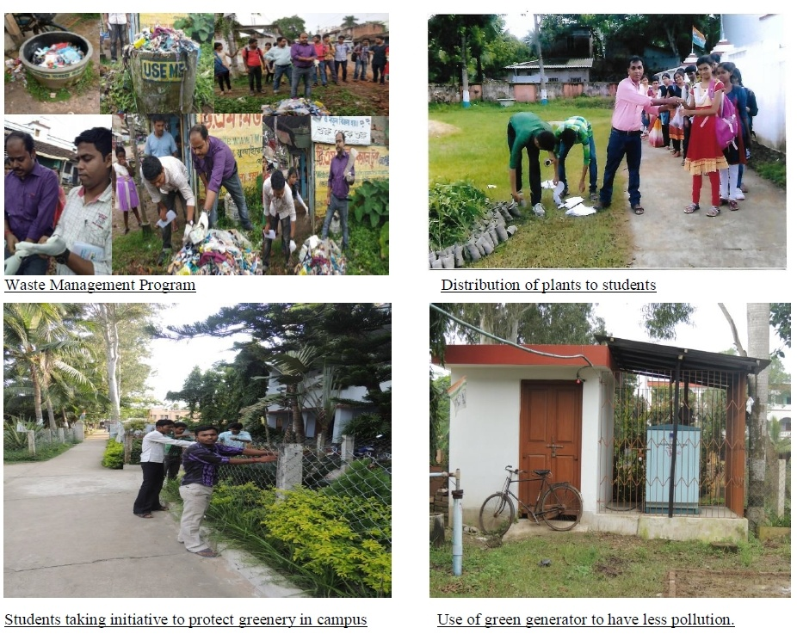

**CARBON FOOT PRINT ASSESSMENT**

**ABOUT:**Carbon Footprint is a measure of total quantity of green house gases being emitted by an individual or an Institution as a result of its daily activities. Carbon Footprint tells the impact on the environment due to various activities inside the campus and quantifies the same in the form of total greenhouse gases being emitted. The most common greenhouse gases are carbon dioxide, water vapor, methane, nitrous oxide and ozone. Of all the greenhouse gases, carbon dioxide is the most prominent greenhouse gas, comprising 402 ppm of the Earth’s atmosphere. There lease of carbon dioxide gas into the Earth’s atmosphere through human activities is commonly known as carbon emissions. The question is what should be done to reduce carbon emissions. Many colleges want to reduce their carbon dioxide (CO2) emissions but it is a difficult task, given a range of factors determine carbon emissions, including mobility, waste, and energy consumption. So, gaining insight into CO2 emissions is extremely important. An important aspect of doing a carbon foot print audit is to account the carbon foot print of the campus by determining the net amount of greenhouse gas emitted from various activities in the campus so that the can adopt better ways to reduce its carbon foot print. One aspect is to consider the d travelled and mode of travel used to commute between home and students and staffs. So the carbon foot print auditing determine the total carbon foot print of the campus and analyzes whether the campus is eco- friendly and follows environmentally sustainable practices. It is therefore essential that any environmentally responsive Institution shall examine its carbon footprint.

#### Key Methodologies adopted for Carbon Footprint Audit

1. A walk through survey was conducted in the entire campus to observe various greenhouse gas emission points.
2. Base Line data was collected by face to face/distributing online question through Google form. To the students and staff also by conducting interviews among staff.

e

1. Walk through survey and base line data collection was done between was done between 2022-23 session.
2. Based on the data collected, the Green House Gas Emission as CO2 Eq from the sources was examined.
3. Observation was done to see whether if the authorities have implemented any Carbon Footprint Reduction Strategy.

n

#### 

#### Carbon Footprint Auditing-Key Findings

Feasible emission inventories were selected to analyze the carbon footprint of the campus. The inventory survey was done for one academic year. The selected inventories are Human Factor, Transportation, Electricity, Solid Waste, Production and Consumption of Food, LPG & Natural Gas.

Data keepers are identified and the primary details were collected. Parameter wise and zone wisedetails were also collected. The received data were assembled and the missing gaps were recognized.

#### Humanfactor

Carbon dioxide emitted by a person per day is not negligible. It is equivalent to the mission of a car in a 5 km stretch. Humans emit 26 giga tons of carbon dioxide per year while CO2 in the atmosphere is rising by only 15 gigatones per year. Just for breathing, humans emit per person each day 1140 grams of CO2,assuming that they eat normally and follow a mean diet of 2800 kcal.The population details of each zone include the total number of teaching faculty; non-teaching staff and students were collected. The carbon dioxide emissions will be larger in the Zone having highest population. As the College Campus is concerned its limit is upto mark.

e

#### Transportation

Fossil fuels are used for transportation. The carbon dioxide emitted by different fuels is indifferent amounts. The engineof the vehicle burns fuel and creates a certain amount of CO2, depending upon its fuel type, fuel consumption and the driving distances. One liter of petrol and diesel emits 2.3 kg and 2.7 kg of carbon dioxide, respectively. Travelling by car for1000km can produce abou t200-230 kg of carbon dioxide in to the atmosphere. If a person travels by a bus for 1000 km, it can add 1075 kg of CO2 to his/her Carbon foot print. Worldwide, the fossil fuels used for transportation contribute over 13% of GHG emissions..

d

The approximate transportation details for the Institution campus like the type of vehicle, No. of vehicles and the fuel used were collected. The carbon dioxide emitted from petrol is less compared to that of diesel. The Carbon footprint by the emission inventory transportation will be quite high.

b

It was noted that the there was no direct transportation under the control of institution but institution encourage Staffs and others to use Electronic Vehicle.

n

#### C:\Users\skbristi.UNIT3\Desktop\New folder (2)\Mugberia College\Photos\2023-24\WhatsApp Image 2024-12-24 at 9.57.35 AM.jpegElectricity

Electricity is one emission inventory which contributesmuch to the Carbon footprint of the Institution. On an average, electricity sources emit 1.297 lbs CO2 per kwh i.e. 0.0005883 metrictons of CO2 perk Wh. The emission factor given by GRID 2010 version 1.1 for hydro electricity is 6.8956x 10-4 metrictons CO2/k Wh. 50 grams of CO2 is emitted from 1unit of solar power.

m

u

The details of the consumption of electricity and the use of generators in different zones were surveyed. If the number of classrooms and labs are more in a zone, consumption of electricity in that zone is more.

It was noted that the Institution uses a lot of Renewable power especially Solar Model as a supplement to convenational power there by reducing emission of GHG to the atmosphere also contributing to the INDC `commitment pledged by Government of India.

n

#### Solid waste

Generally,1kg of solid waste is generated percapita per day. For high income countries, the solid waste generation is 1.1 – 5 kg percapita per day.For middle income 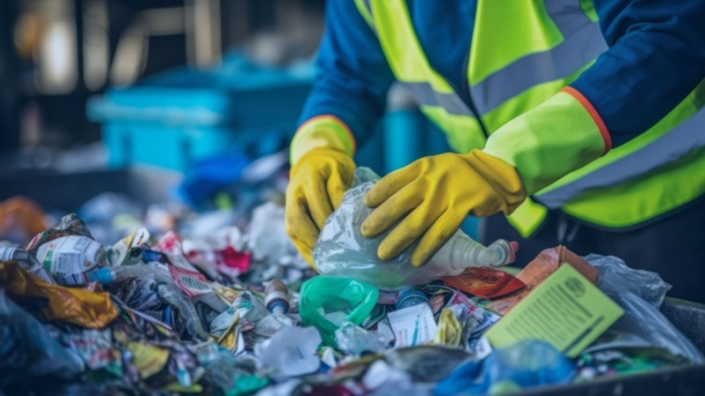countries, it is 0.52-1 kg and for low income countries the value is 0.450.89 kg/ capita/ day. One kilogram of solid waste can emit about 0.125 kg of carbon. The details regarding the solid waste generated in each zone is collected including the waste produced in canteen and hostels.

s

The solid waste generated in the canteen and hostel which is taken out of the campus comes under other indirect emissions. Solid Waste emits less amount of carbon dioxide compared toother emission inventories considered.Their Solid waste disposal process found ok, so exposure is less.

#### LPG And Natural Gas

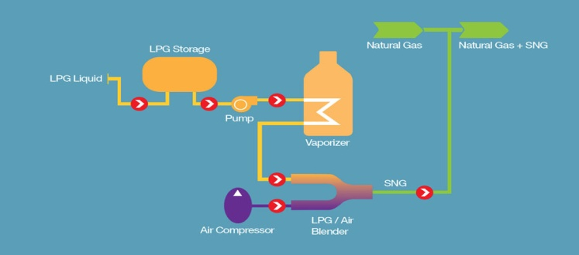The consumption of 1L of LPG can release 1.5kg of CO2 to the atmosphere. Also, burning ofwood (250kg) can add 33kg of CO2 to the Carbon footprint. The consumption details of LPG and Natural Gas in canteen and hostels were surveyed. It was noted that the Institution uses normal limit of LPG as required.

#### Carbon Footprint Analysis

Carbon footprint analysis can be done by suitably combining data collected with respective emission factor of the selected emission inventories. Table represents emission factors of the selected inventories.

#### Best Practices Observed in the Institution–Carbon Footprint Reduction

* Restriction of personal vehicle inside the campus enhancing reduction of carbon footprints.
* Use of bicycles to avoid the primary oil consumption observed in college campus.
* Use of Solar system power the Instutution thereby reducing dependence on Conventional power.
* Use of Solar Lamps to light the Walk ways
* Use of limited LPG to Run the Kitchen
* Use of Walk ways to commute short distances
* All over the Campus the Green Area much more then the Working area.

**Suggestions and Recommendations**

* The primary power electricity used by the Institution also they have installed Secondary power Solar panel, in this context, solar energy also used as alternative energy source in the College campuses to reduce the dependency and Carbon emission
* The use of plastic products should be banned in the College campuses.
* The College campuses are nodoudtbiodiversed but more plantations speciallymedicialplanntations are required in the campuses. Plantation of fruit plants will attract more birds.
* There is urgent need to form a Green Monitoring Team. The priority of this body is to maintain the greenary of the College campuses
* The Green Monitoring Team sould consist of members from teaching staffs, non-teaching staffs, students and if possible, try to include some local interested people.
* Sustainable use of resources and ecological balance of the College campuses must be maintained throuout the year.
* Increse the use of Electrical vehicle to reduce the pollution.
* Encourage use of Bicycles..
* Promote awarnessbuildup programme on Environmental Issues time to time

**Conclusion:**

Focus on Environment is applicable. The MUGBERIA GANGADHAR MAHAVIDYALAYAYA have proper plan for Future Development on Environmental expect.

We have also suggest them how to improve the Environmental expect in a better way.

Audit conducted by “Management System Consultancy”

Auditor



Amalesh Kumar Mandal

(IRCA Accredited Lead Auditor on Quality, Environment, Energy Management System, Empanelled Auditor from IAF accredited Certification Body, Energy Management System Auditor from National Productivity Council, Environment Management System personnel from National Safety Council, ISO 17020:2012 Competance Certified for Quality Council of India and Carbon Frootprint Calculator Certified from BSI)