List of students qualifying in state/national/ international level examinations during 2019 -22
(eg: JAM/GATE/ NET/SET/CTET/CLAT/GMAT/CAT/GRE/ TOEFL/ Civil Services/State Government Examinations, etc.)
Department of Mathematics(UG & PG)
Mugberia Gangadhar Mahavidyalaya
SUMAN DAS  B.Sc:2023  Reg No:MA618F382 | 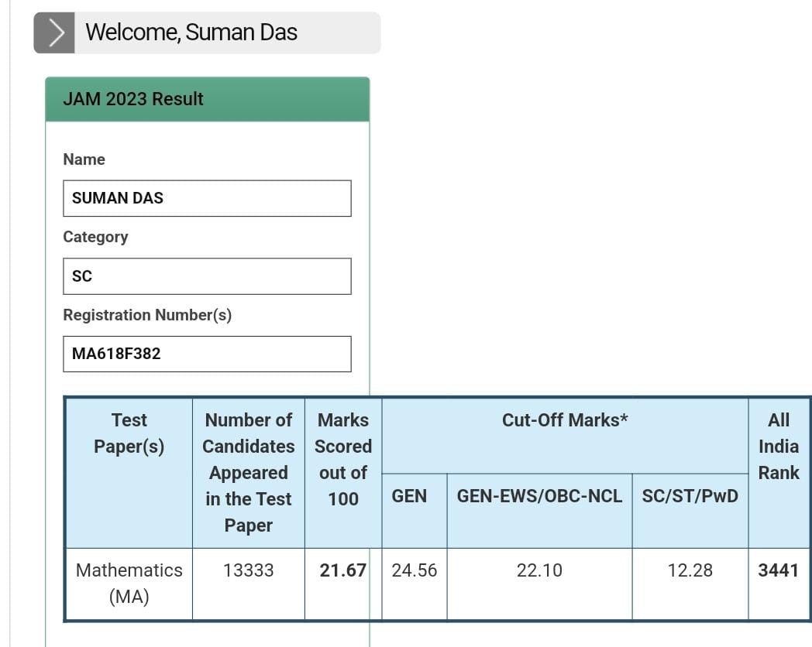

SONALI MANDAL  B.Sc:2023  Reg No:MA616F244 | 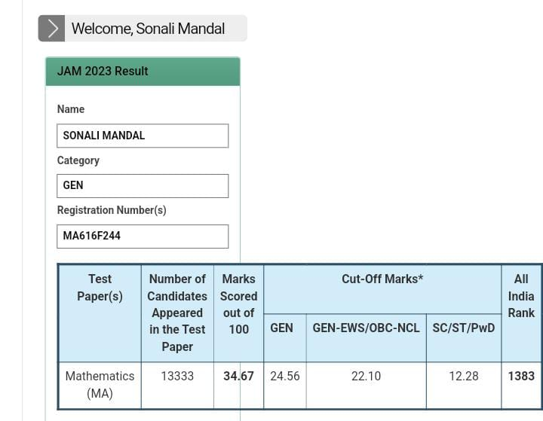

SOUMYADEEP BEJ  B.Sc:2023  Reg No:MA616F444 | 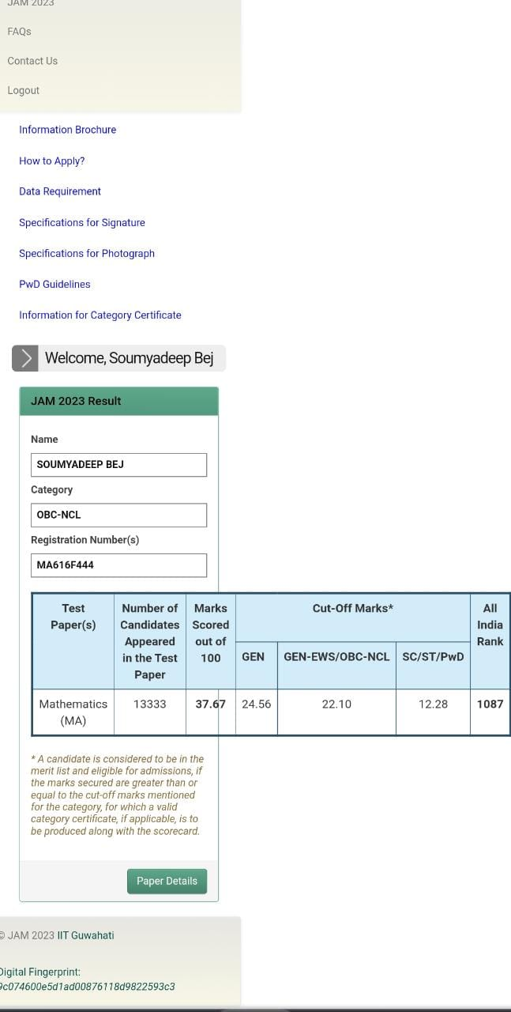

Jatindranath Samanta  B.Sc:2023  Reg No:MA616F358 | 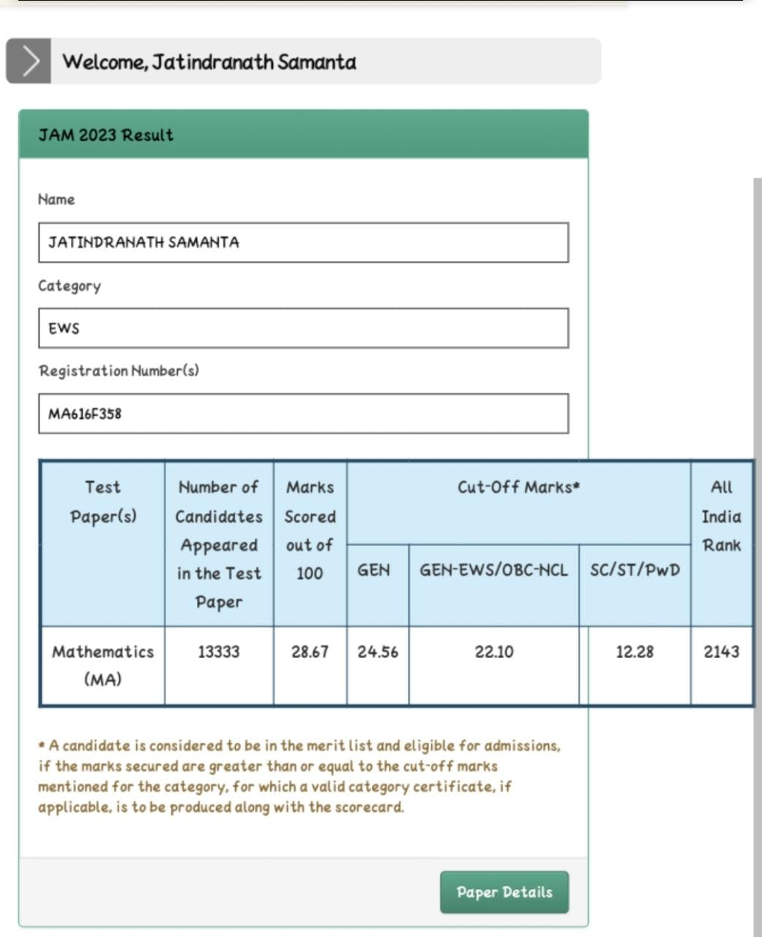

Amiyendra Maiti  B.Sc:2023  Reg No:MA616F290 | 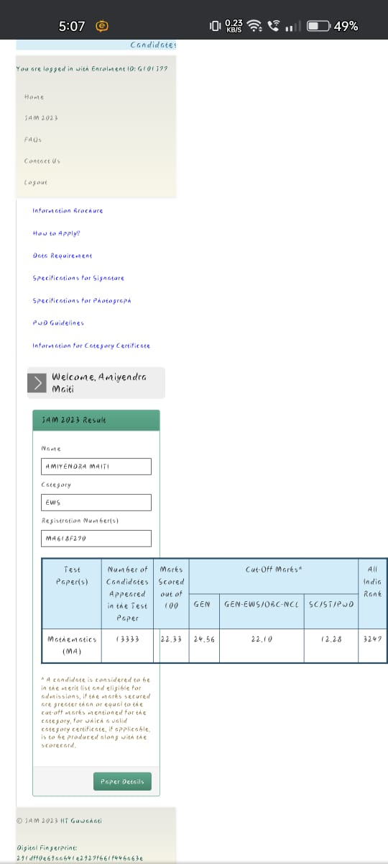

Goutam Jana  M.Sc:2023  Reg No:MA23S56509229 | 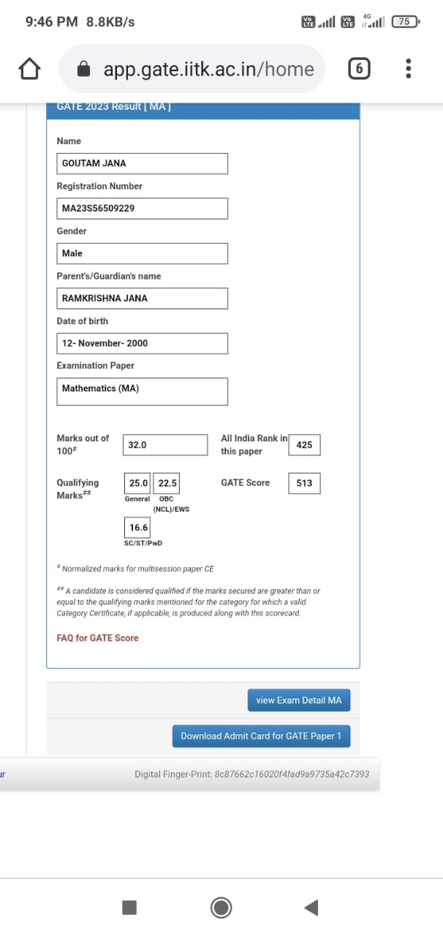

Bithi Maikap  BSc:2022  Reg No:MA23S54030002 | 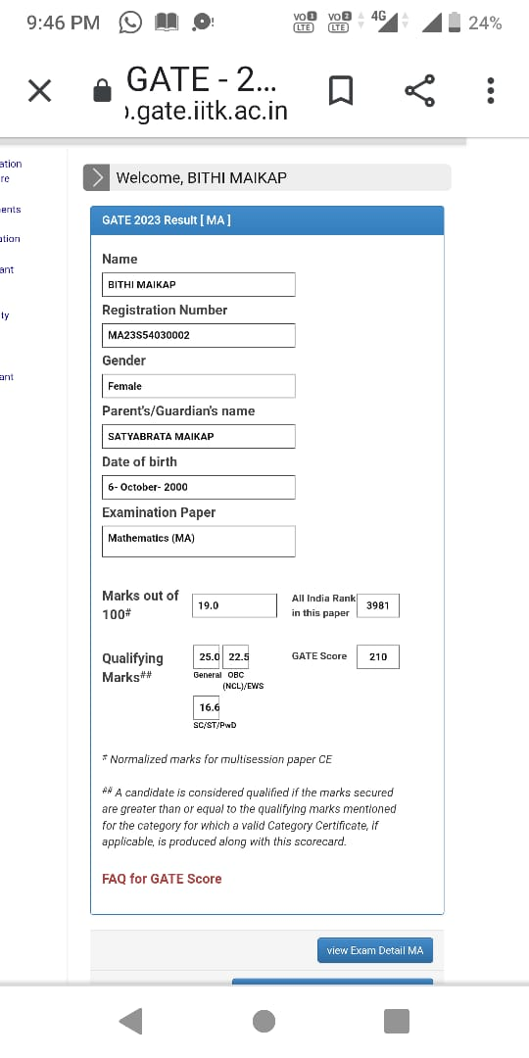

SUKHENDU DAS ADHIKARY  MSc (Mathematics): 2019  Roll No: WB10606188  NET -LS | 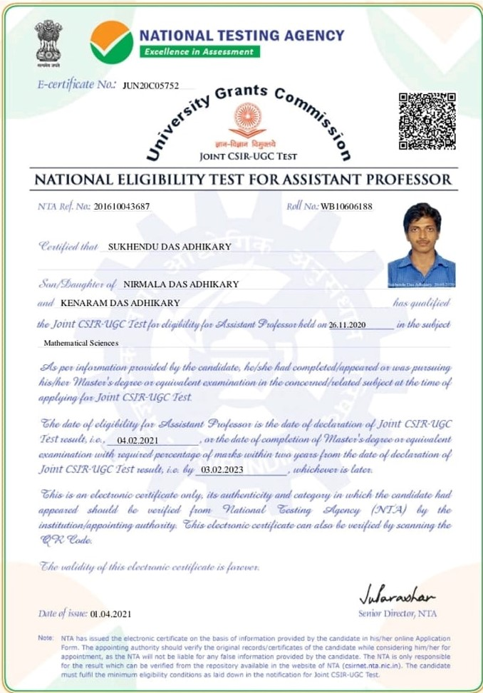
BUBUN DAS  BSc Mathematics :  NET -LS  JUNE -2020  ROLL NO-  WB10606513  Mob: 8145359009 | 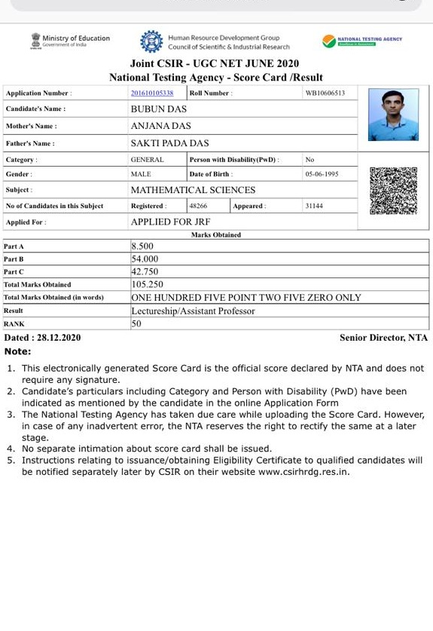

SUNAYANI MONDAL
MSc Mathematics :2020
JRF-NET 2021
AIR :220
Roll No: UP18001741
Mob: 9083962561

SUBHASISH DAS  GATE 2021 (Mathematics)  Reg. No: MA21S56042274  Mob: 7063765207 | 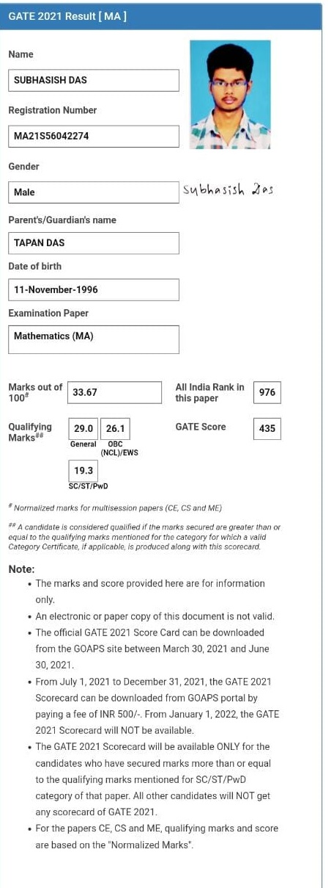

Rabindranath Bhoj  GATE-2021  Reg No-MA21S56035032  All India Rank: 243  M.Sc Mathematics  Pass out: 2020 | 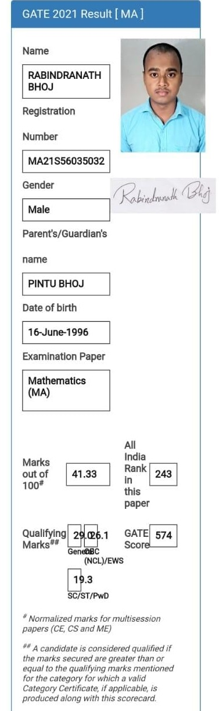

SANDIP DAS  GATE-2021  Reg No-MA21S56035152  All India Rank: 1326  M.Sc Mathematics  Pass out: 2020 | 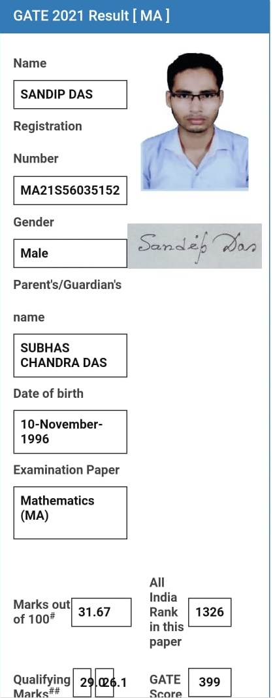

Ramkrishna Bar  GATE 2021(Mathematics)  MA21S56035052  AIR-3050 | 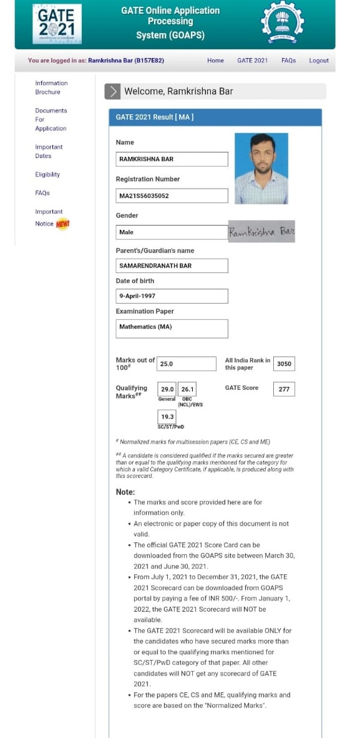

BUBUN DAS  Reg no-MA21S56042022  All India Rank: 611  M.Sc Mathematics  Pass out:  Mob:8145359009 | 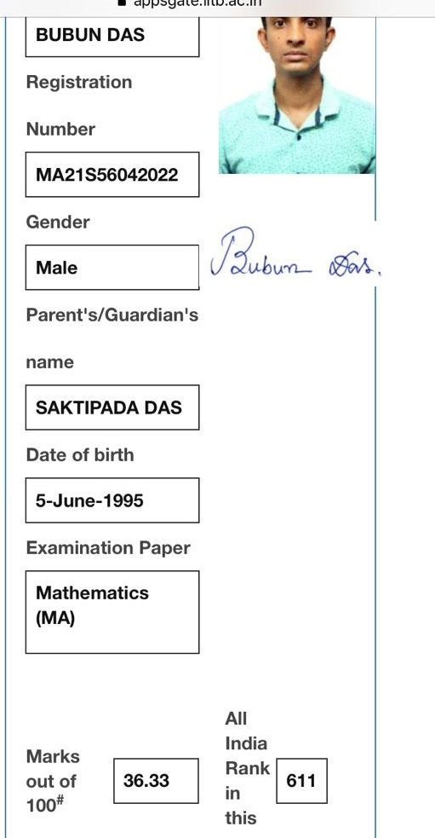

SUKHENDU DAS ADHIKARY  GATE-2021  Reg No-MA21S56036019  All India Rank: 1206  M.Sc Mathematics  Pass out: 2020  Mob: | 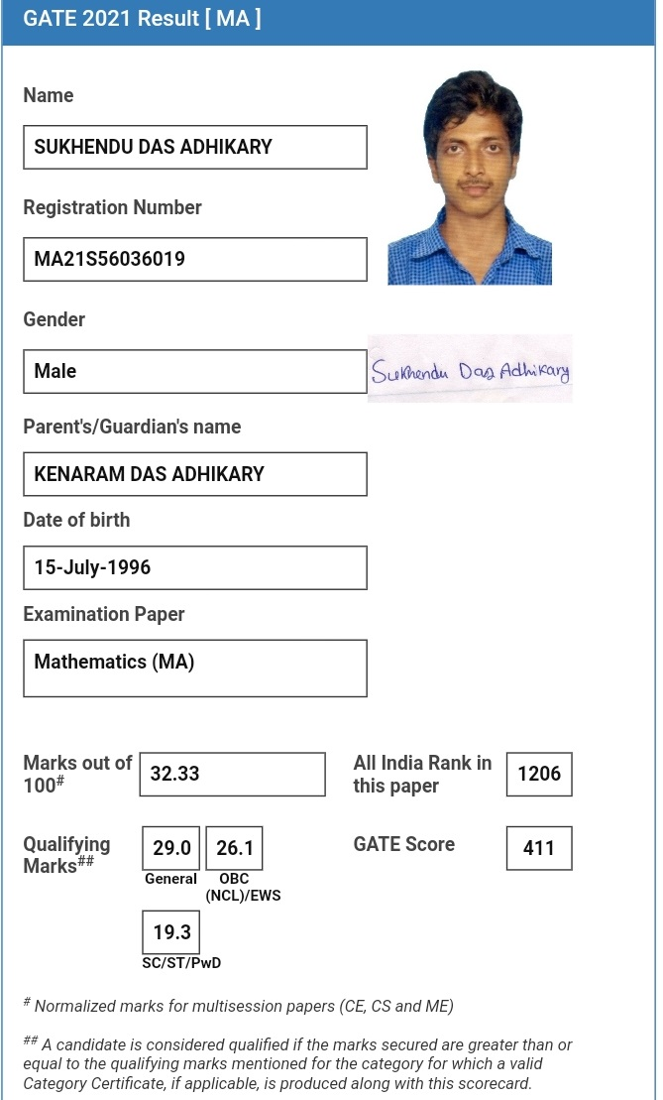

SUNAYANI MONDAL  MSc Mathematics :2020  GATE (MA) 2022  MA21S56033041  Mob: 9083962561  AIR-5457 | 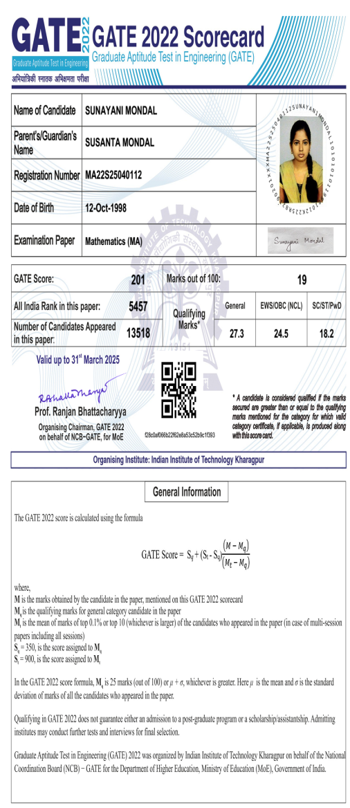

SRIKRISHNA DAS  JAM(MA): 2021  Reg. No. MA614A526  AIR-324 | 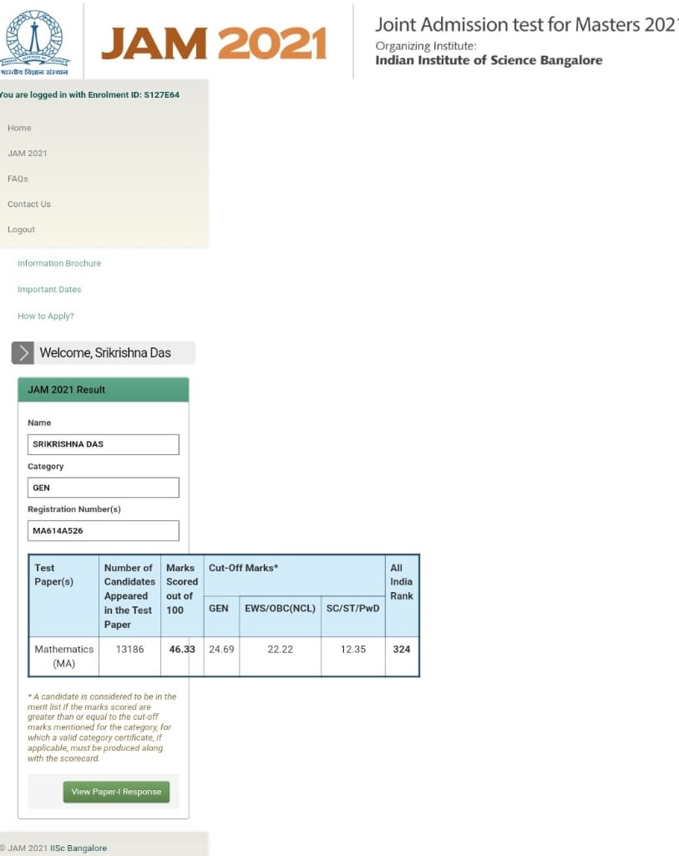

SUBHADIP SAHOO  JAM (MA) 2021  Reg. No. : MA613A243  AIR-1094 | 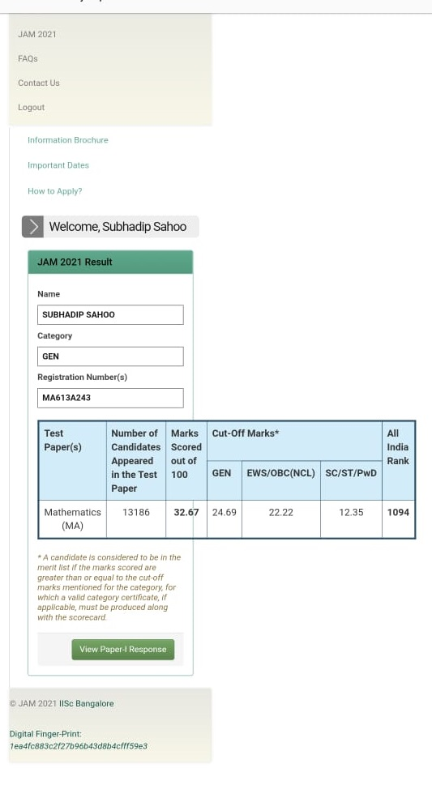

MeghaSantra  JAM (MA) : 2022  Reg. No. :MA615A462  AIR-1193 | 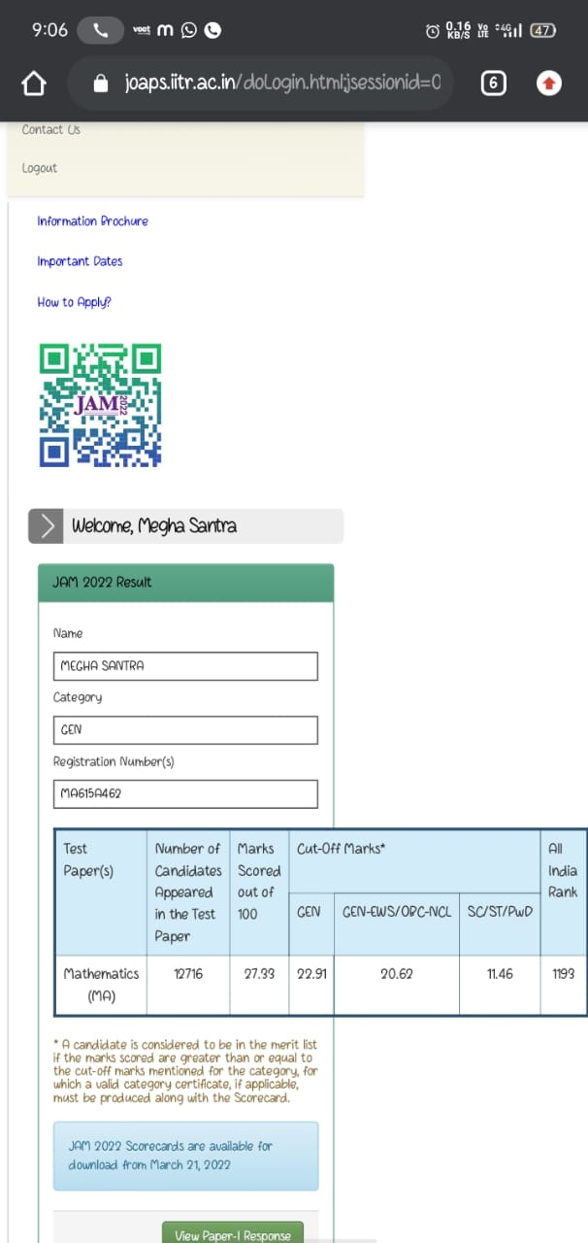

Anwesha Samanta
JAM(MA): 2022
MA615A182

AIR-1554

Sourav Das  JAM (MA): 2022  Reg. No.-MA619A185  ALL INDIA RANK:1730 | 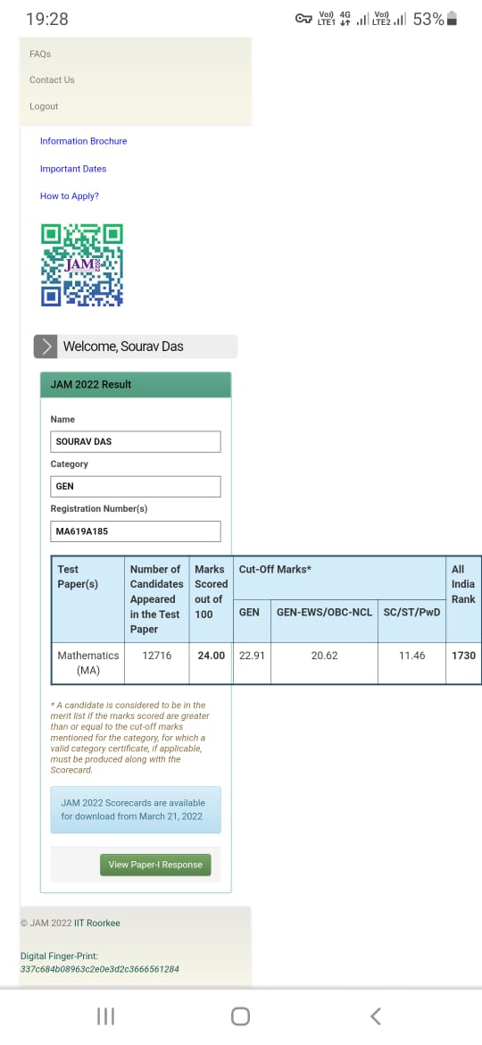

BithiMaikap  JAM (MA): 2022  Reg No. -MA614A021  AIR:5468  Mob: | 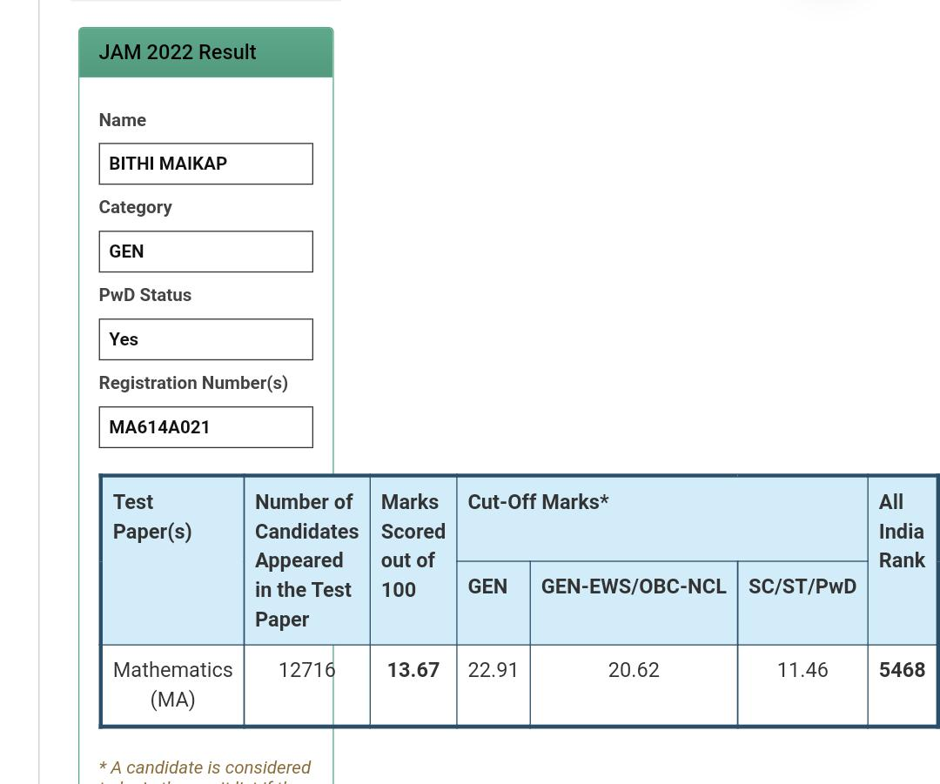

RABINDRANATH BHOJ  M.Sc.: 2020  GATE(MA)-2022  Reg No-MA22S26507319  AIR: 487 | 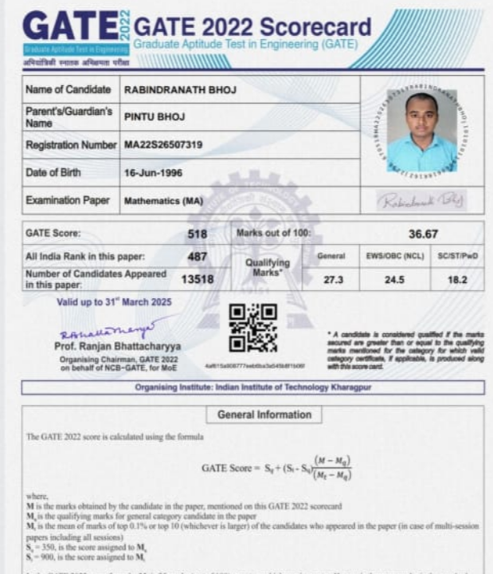

Sukhendu Das Adhikary
M.Sc.-
GATE(MA): 2022
Reg No: MA22S26507537

PARAMITA BHUNIA
ROLL NO-210014362
CTET

MANISH ACHARYYA
M.Sc.-
GATE (MA): 2022
Reg. No.-MA22S26507527
AIR-1195

Subhasish Das

Roll No (CTET): 173160811630157

Rabindranath Bhoj
M.Sc. 2020
CSIR-JRF (Math)- Jne2022
Roll No. WB1011240136

Tushar KantiBera

Roll No (CTET) : 173160811631684

SUKHENDU DAS ADHIKARY  MSc: 2019  Roll No : WB07000340  NET-JRF | 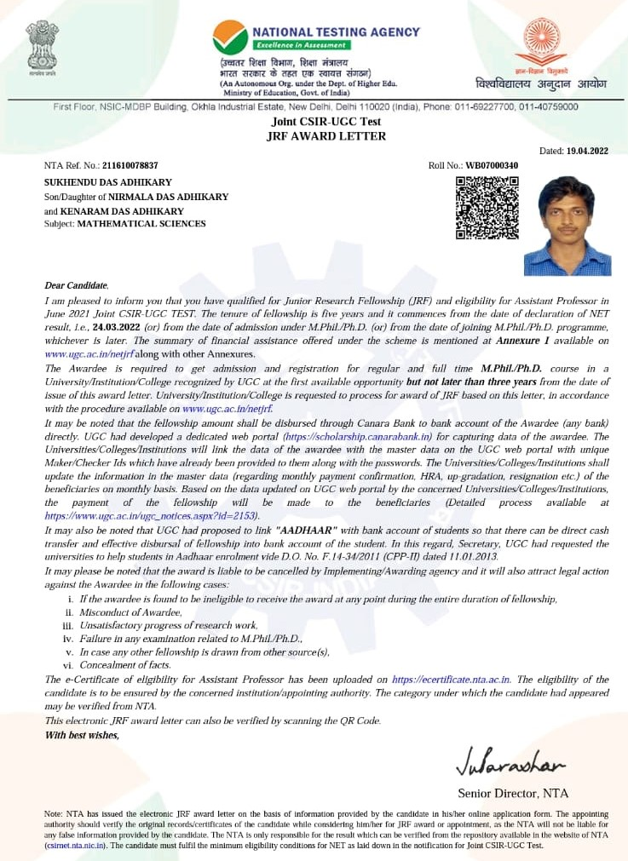

SUBHENDU BHUNIA  MSc: 2022  Reg No : TET220413018 | 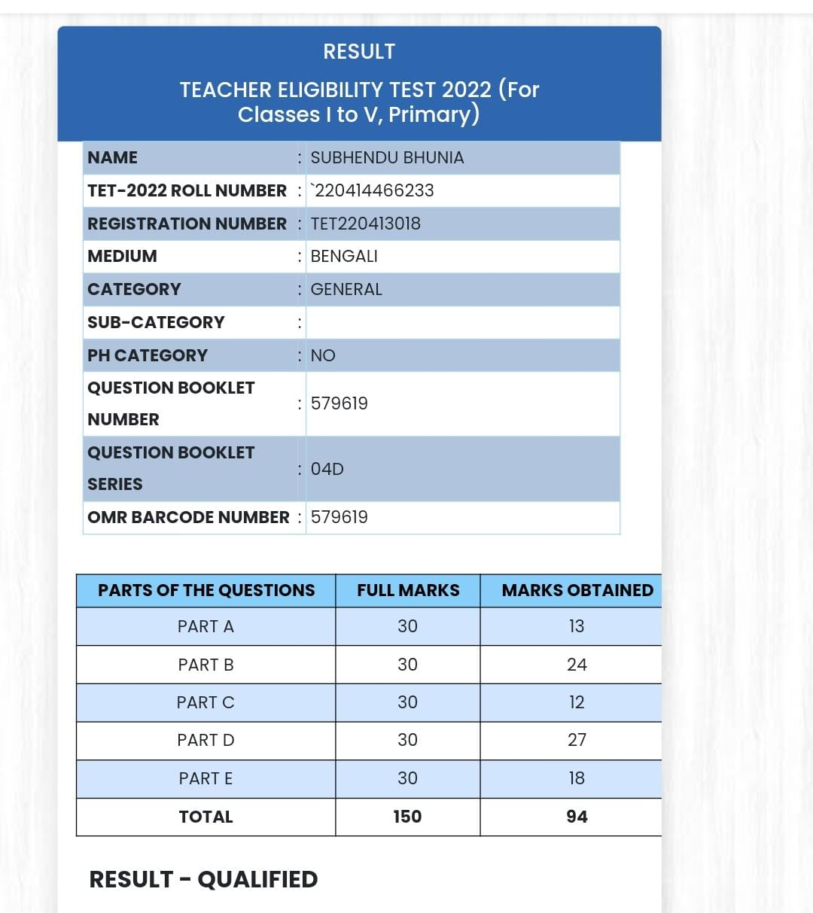

PRATHAMA SAMANTA  MSc: 2019  Reg No : TET220074917 | 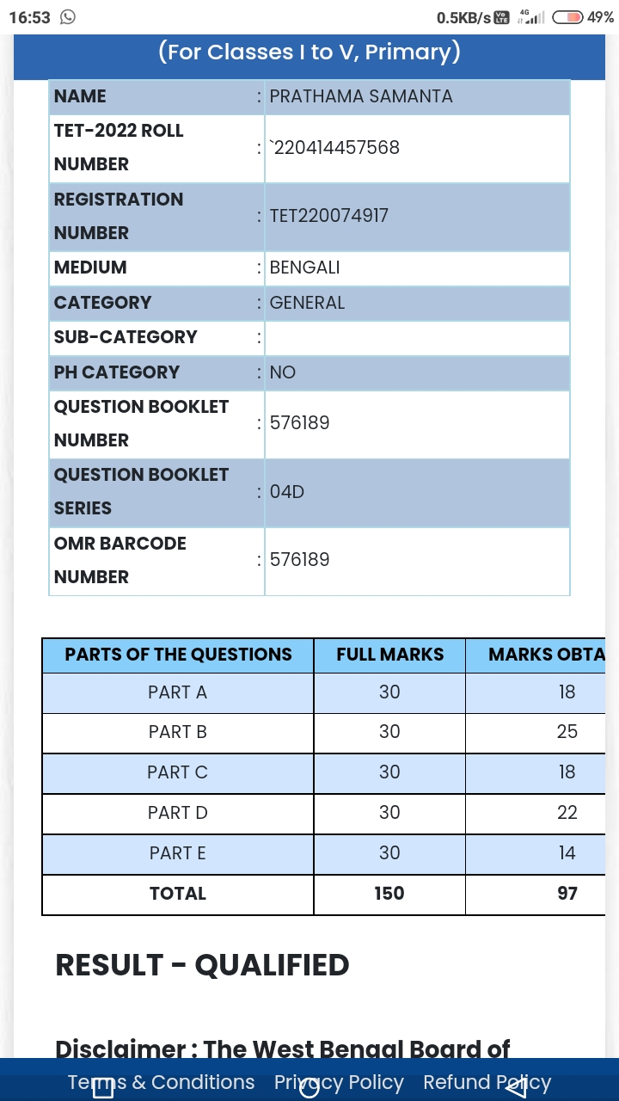

SOUMEN JANA  MSc: 2019  Reg No : TET220672226 | 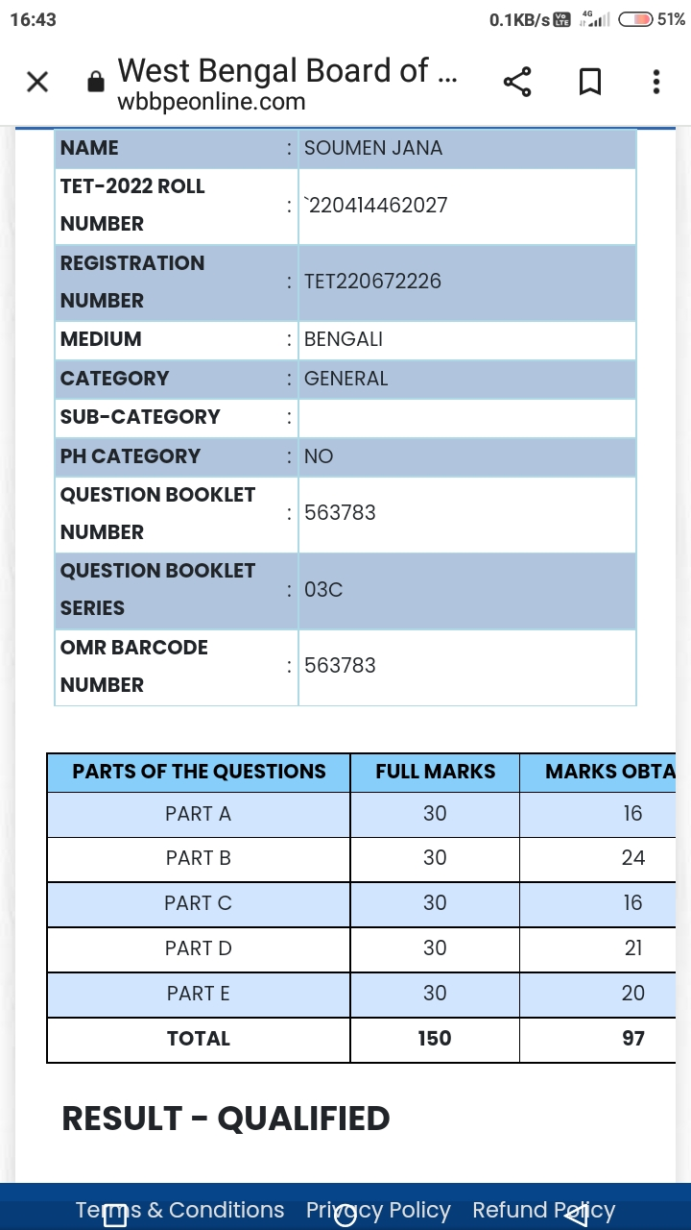

SOUGATA BERA  MSc: 2022  Reg No:TET220396334 | 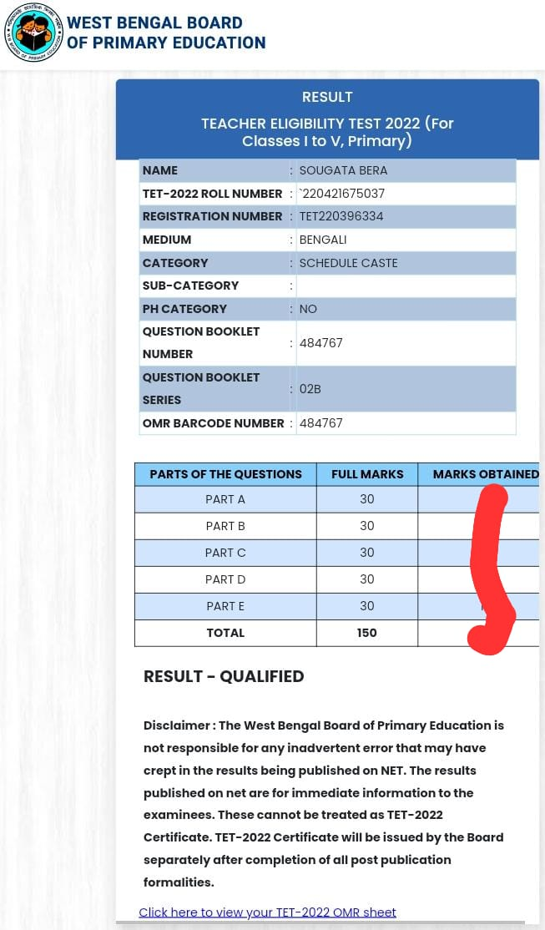

NIRMAL DAS  MSc: 2019  Regl No : TET220412487 | 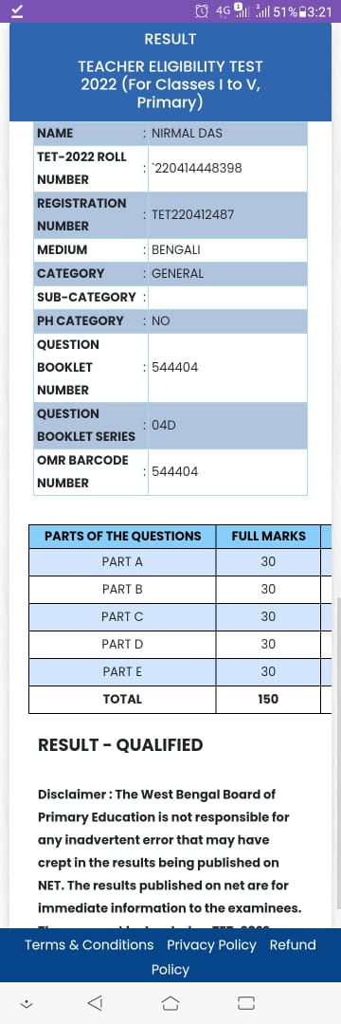

SUBHASISH DAS  MSc: 2020  Reg No : 220414458662 | 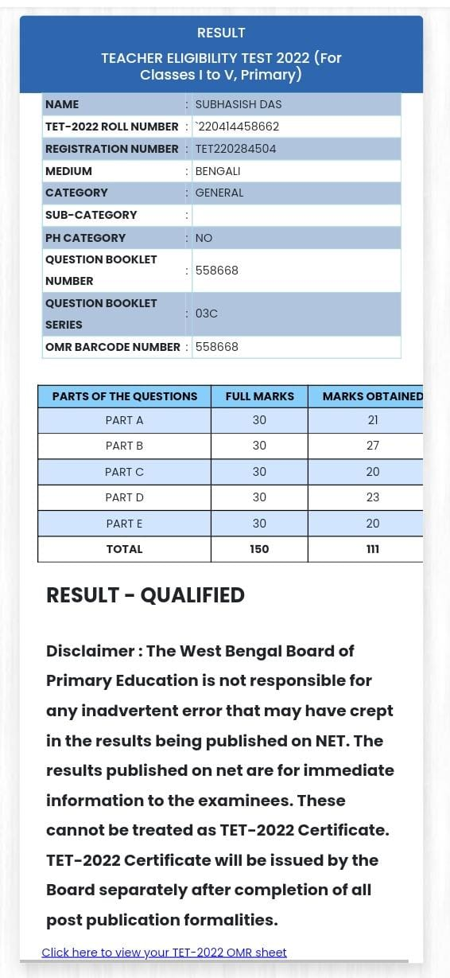

DURGA MANDAL  MSc: 2021  Reg No : TET220158750 | 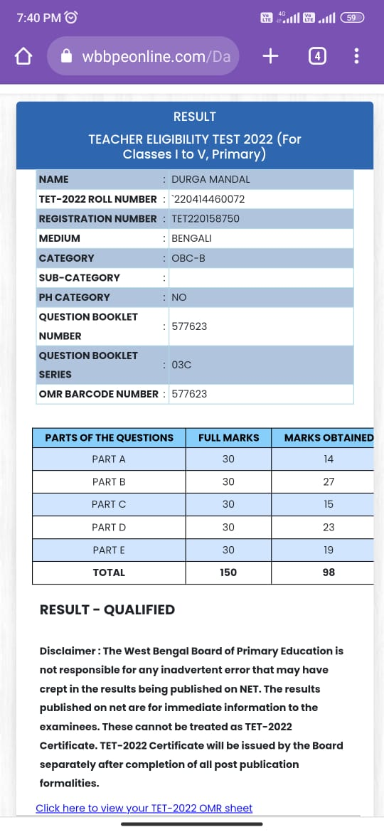

MINAKSHI SARANGI  MSc: 2020  Reg No :TET220502211 | 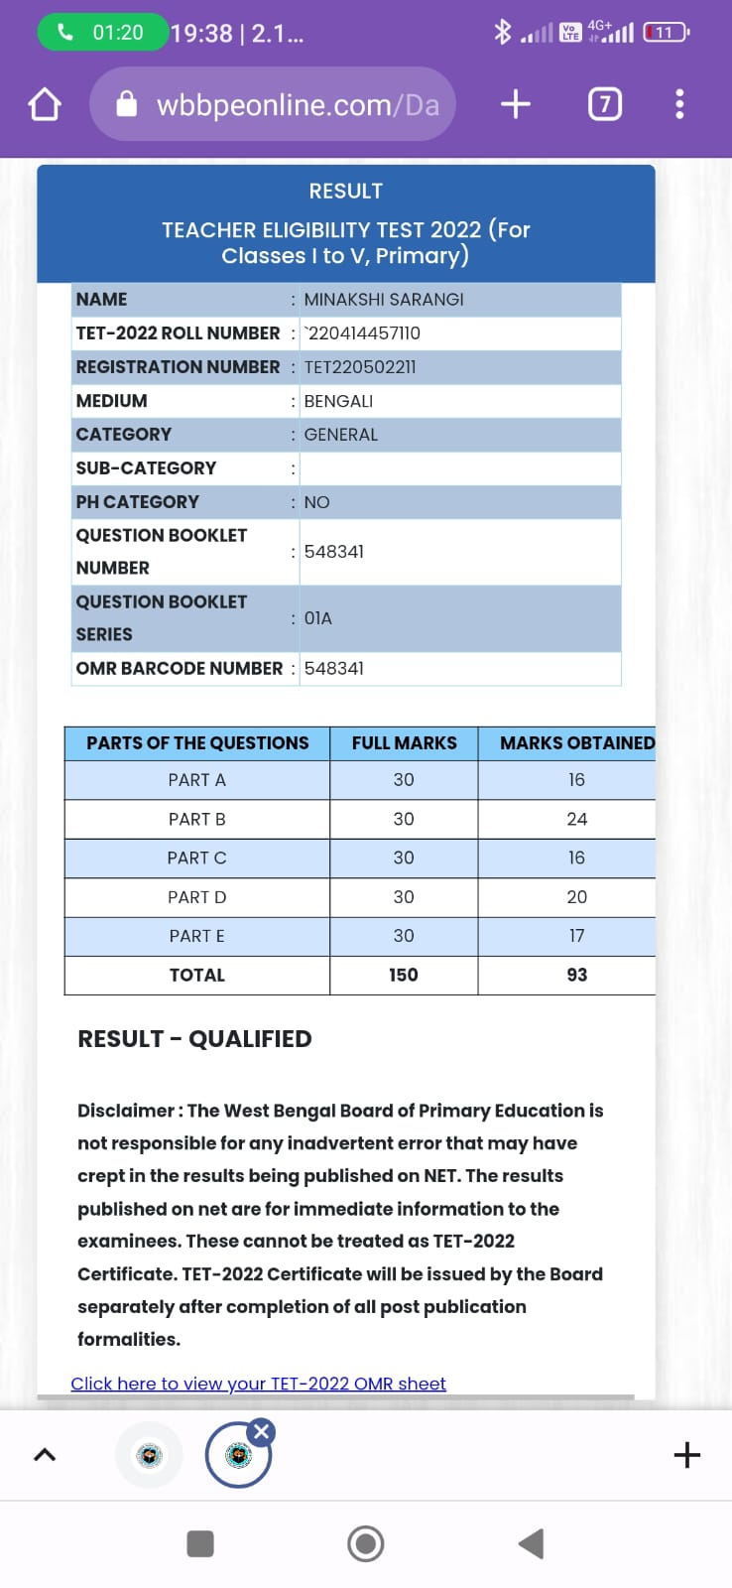

MADHUSUDAN MIDYA  MSc: 2021  Reg No : TET220203973 | 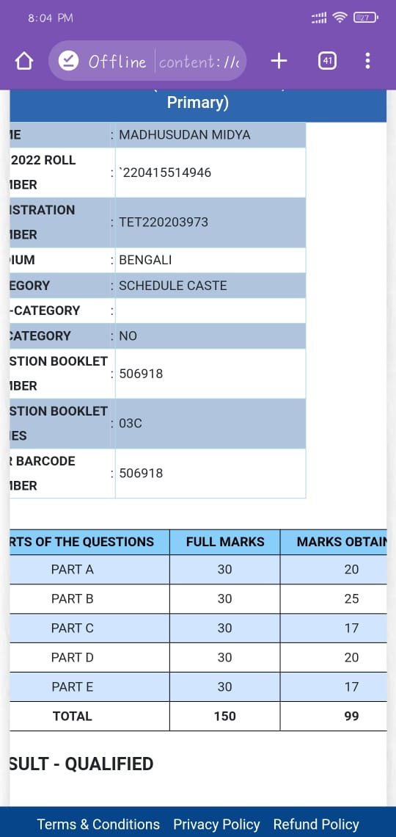

SUBHA PRADHAN  MSc: 2022  Reg No : TET220282108 | 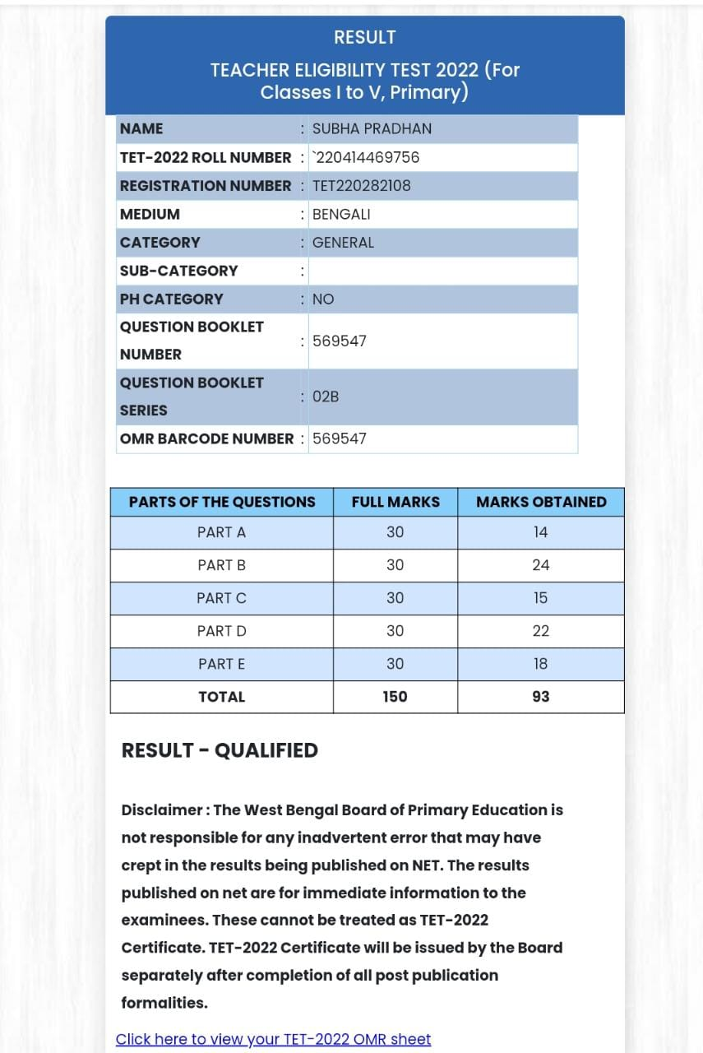

SOUMENDU NANDA  BSc: 2020  Reg No : TET220617503 | 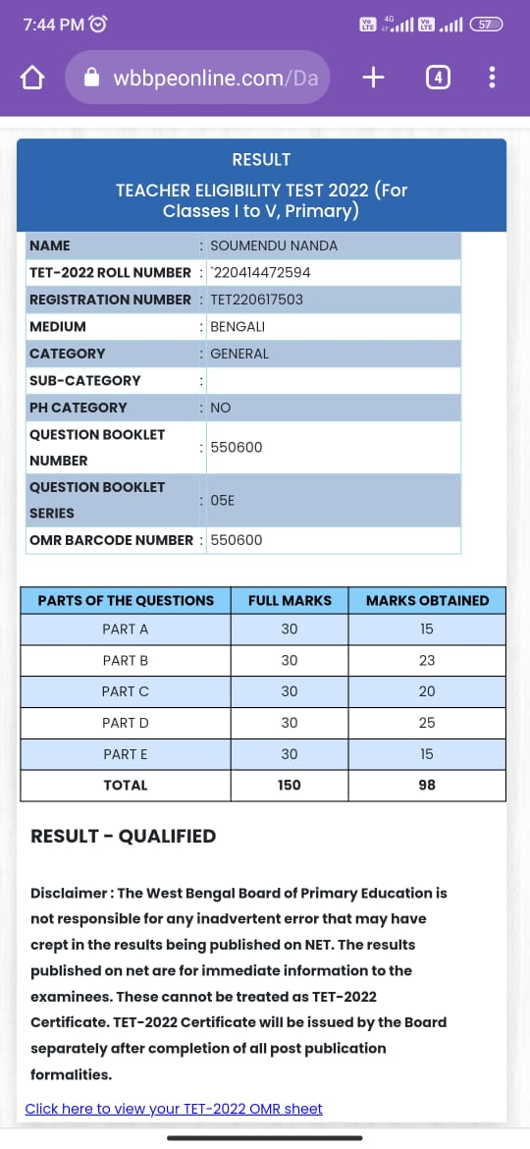

PABITRA MONDAL  BSc: 2022  Reg No : TET220109651 | 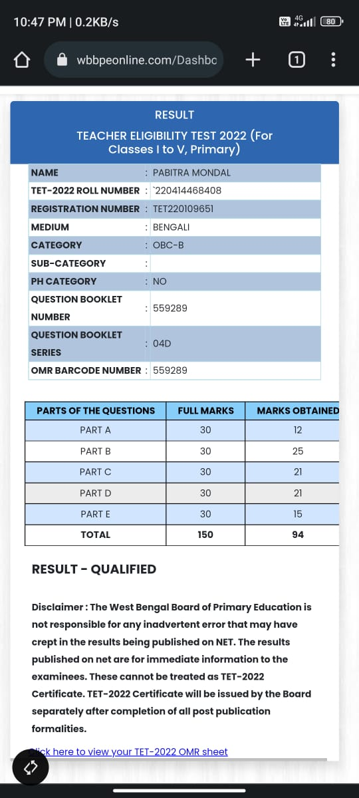

PALLABITA MAITY  MSc: 2021  Reg No : TET220089048 | 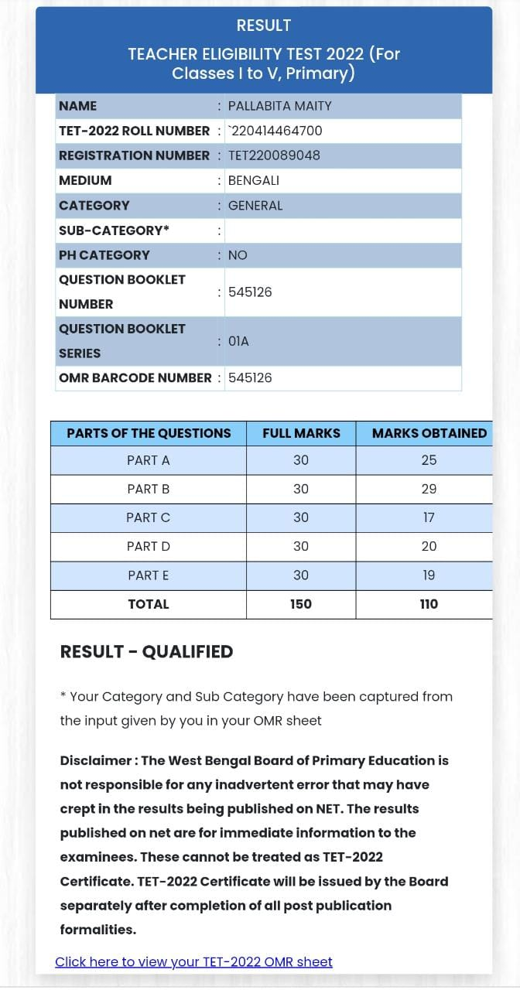

TUSHAR KANTI BERA  BSc:  Reg No : TET220190749 | 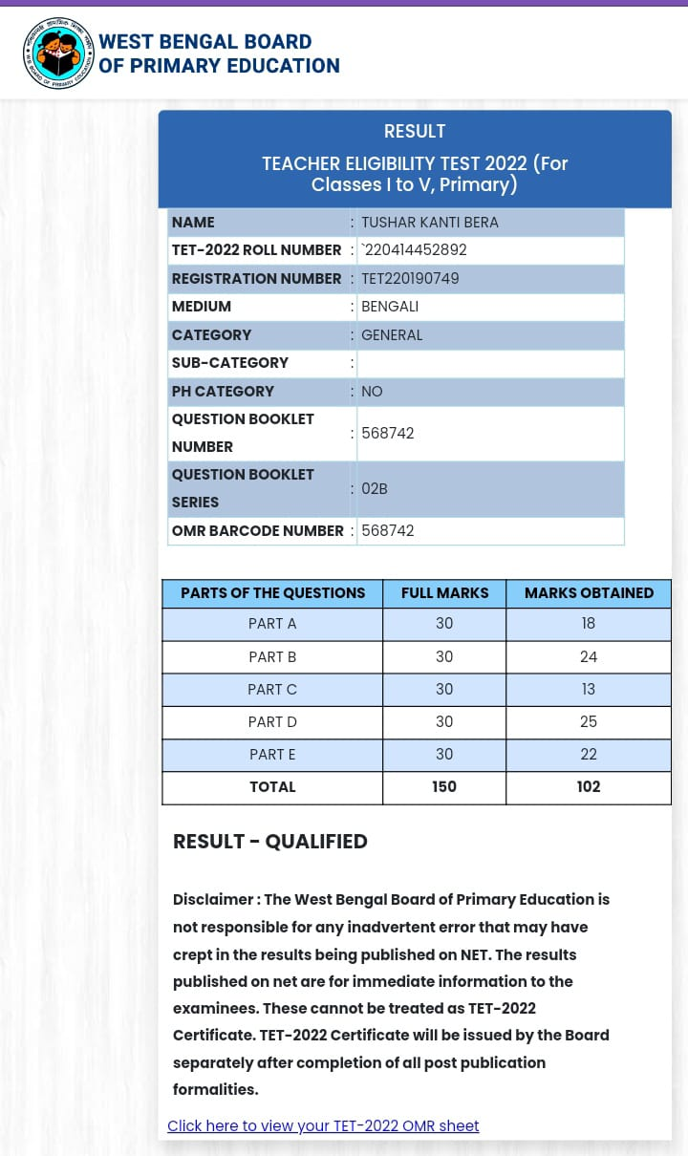

BHAGYASHREE JANA  BSc: 2020  Reg No : TET220131908 | 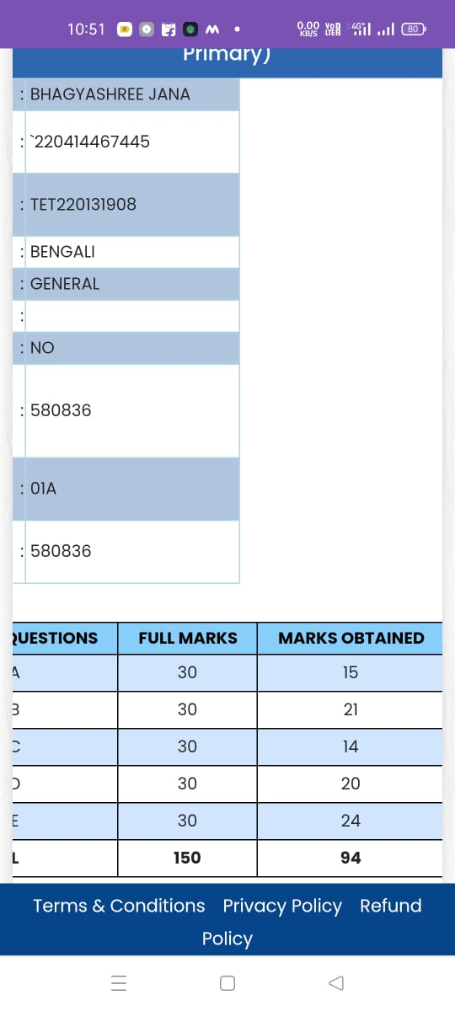

BISWARANJAN MANNA  MSc: 2022  Reg No :TET220468719 | 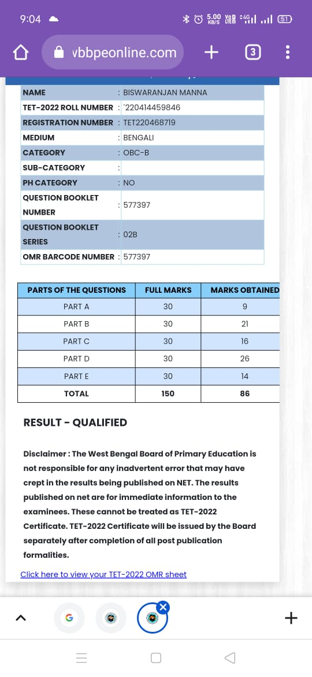

PRITI CHANDA  BSc: 2020  Reg No :TET220137947 | 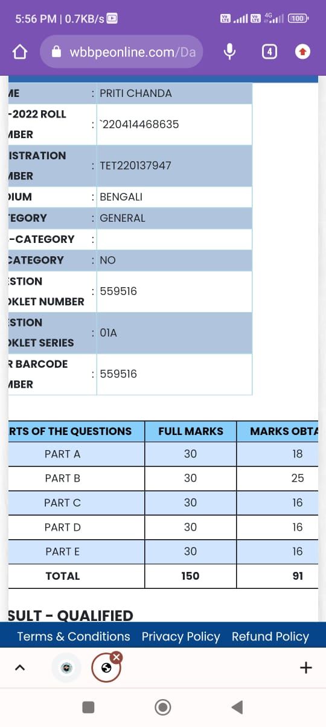

SANCHITA MAITY  MSc: 2019  Reg No : TET220318416 | 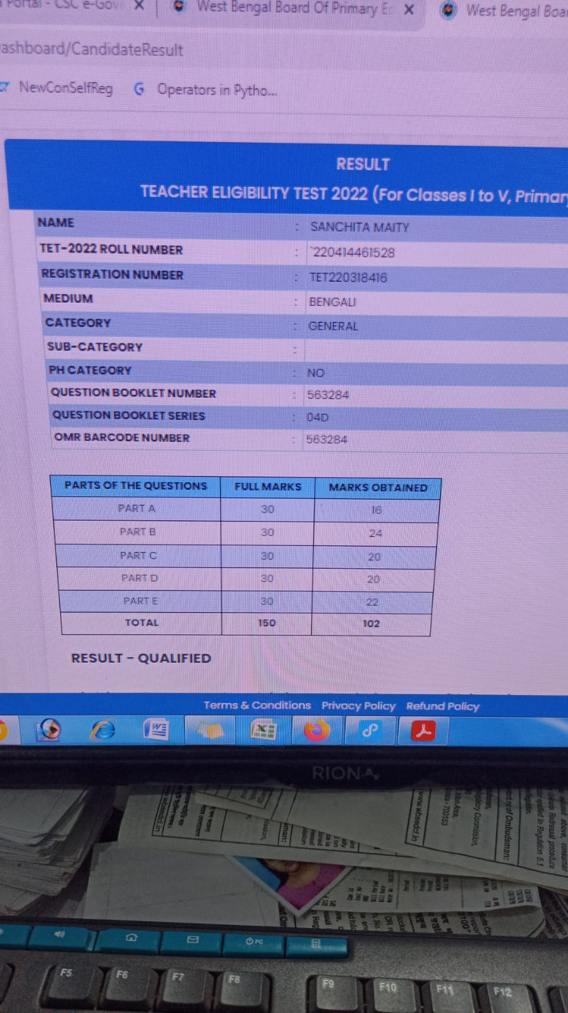

NANDITA PRADHAN  MSc: 2021  Reg No :TET220304696 | 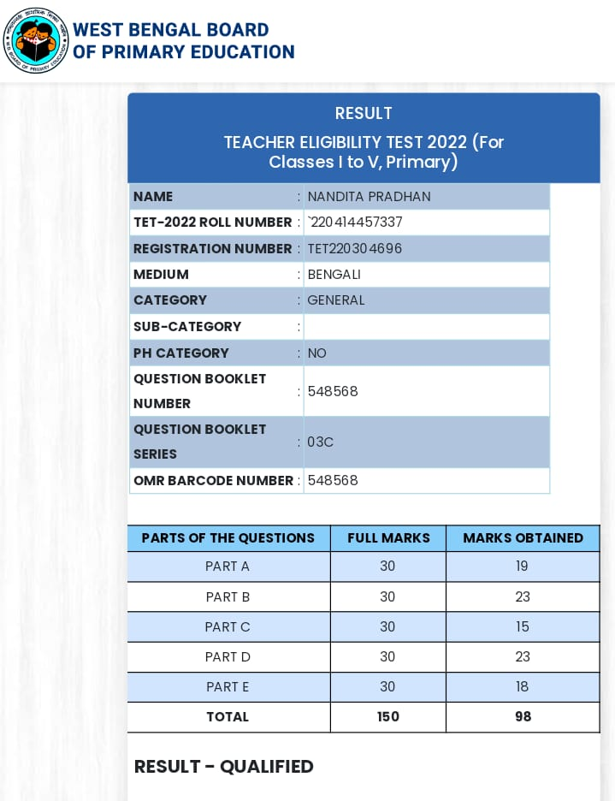

SOUMAVA DAS  BSc: 2019  Regl No : TET220204188 | 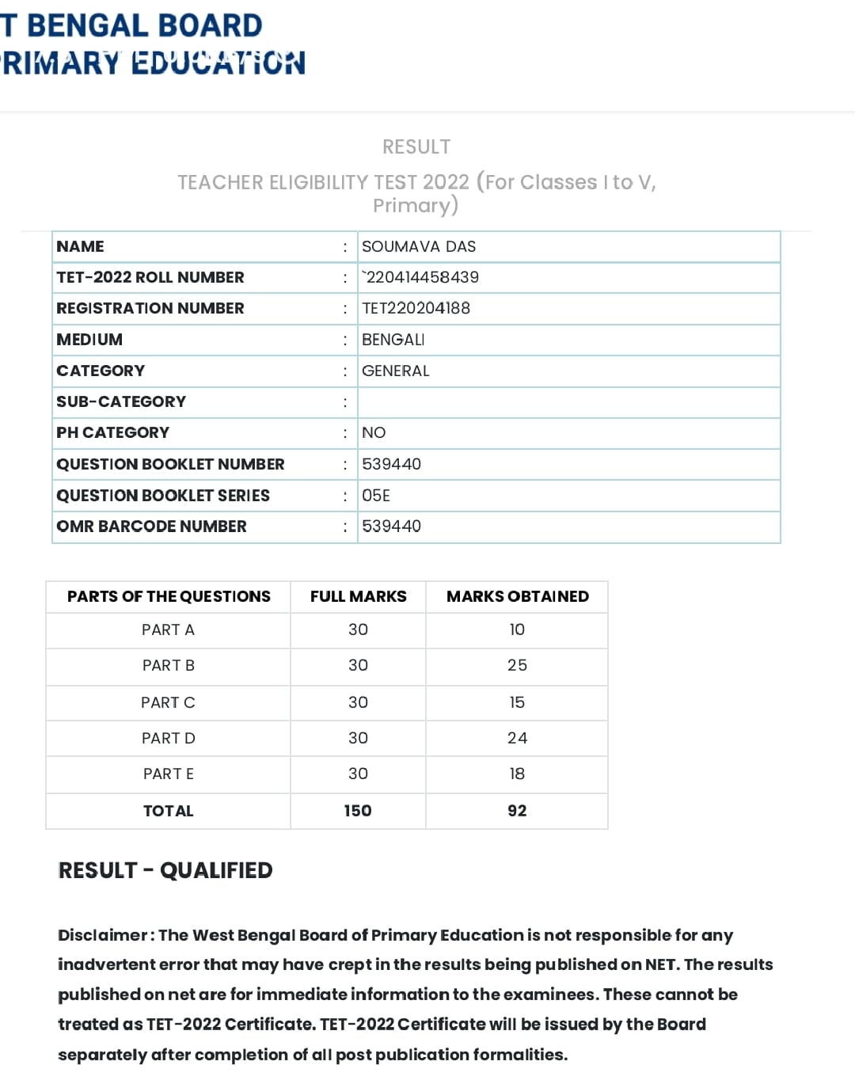

CHANDAN GIRI  MSc: 2021  Reg No :TET220021173 | 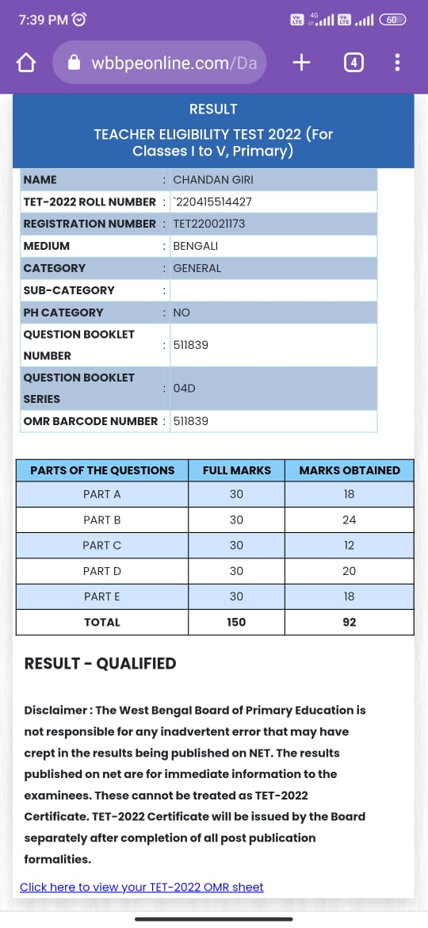

PUSPITA JANA  BSc: 2020  Reg No : TET220290141 | 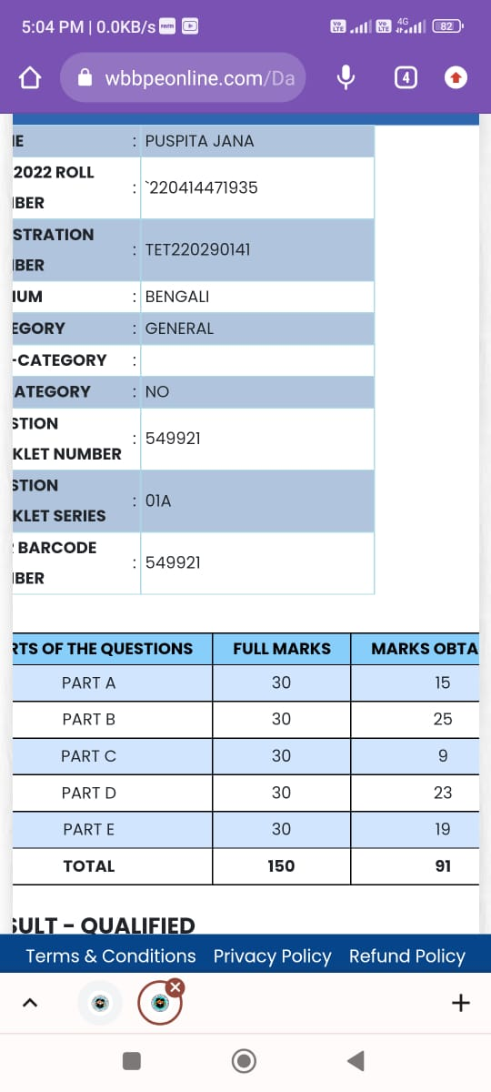

MAMATA BIRING  MSc: 2020  Reg No : TET220249817 | 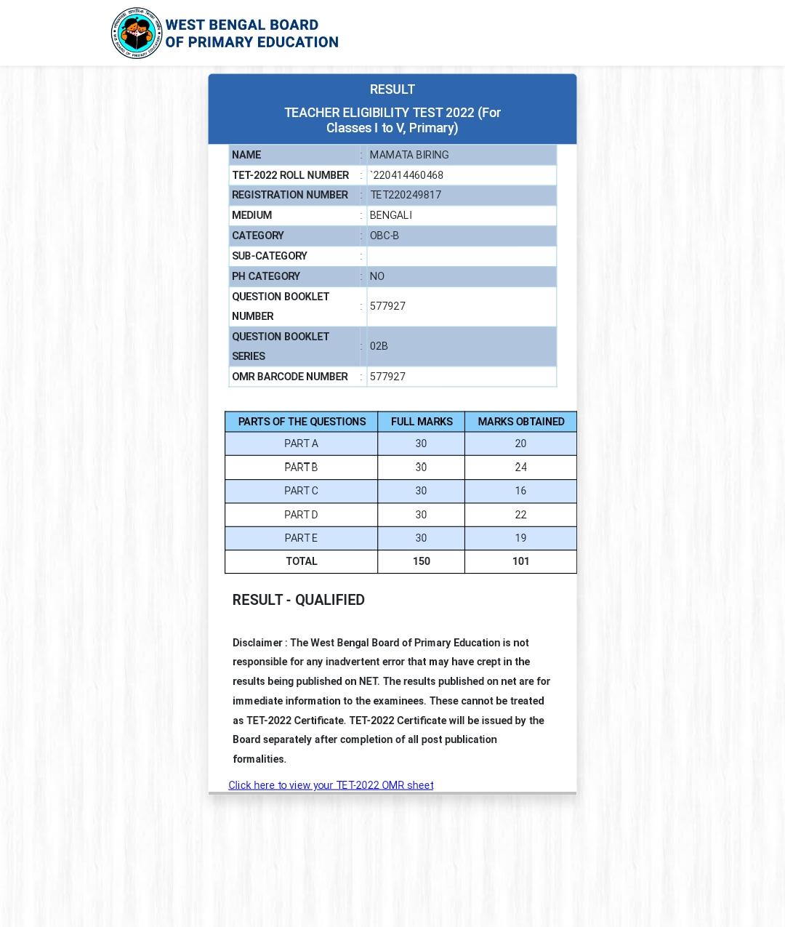

MOUMITA SAHOO  MSc: 2021  Reg No : TET220484703 | 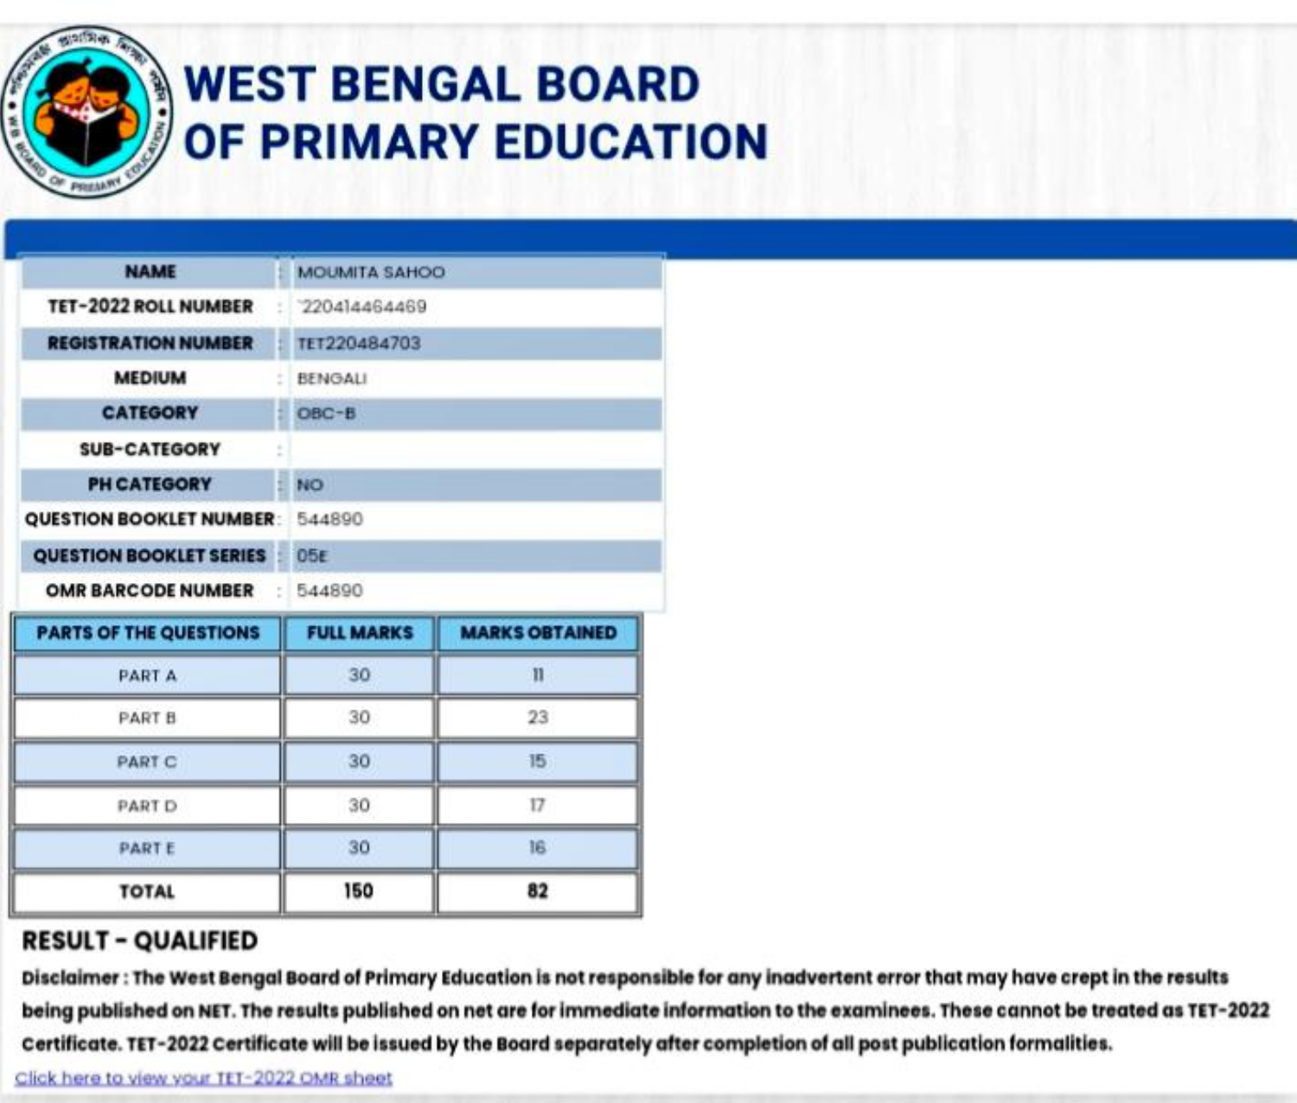

SUDIP MISHRA  MSc: 2020  Reg No :TET220283845 | 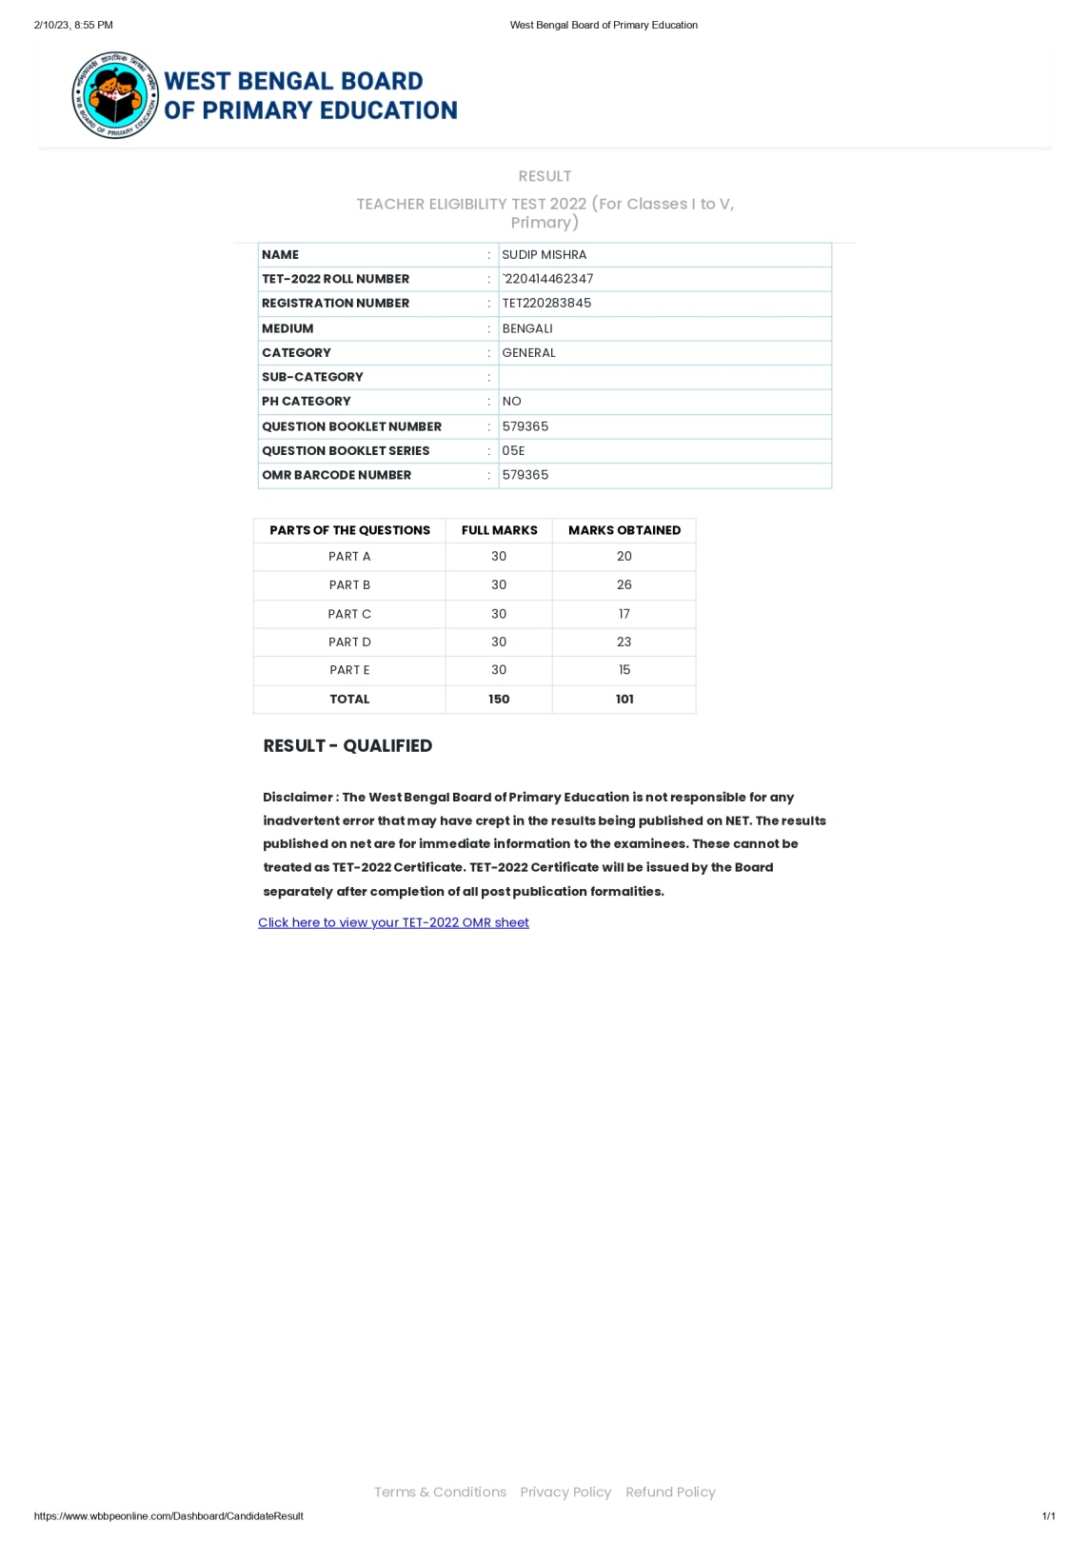

ANINDITA JANA  MSc: 2020  Reg No : TET220271786 | 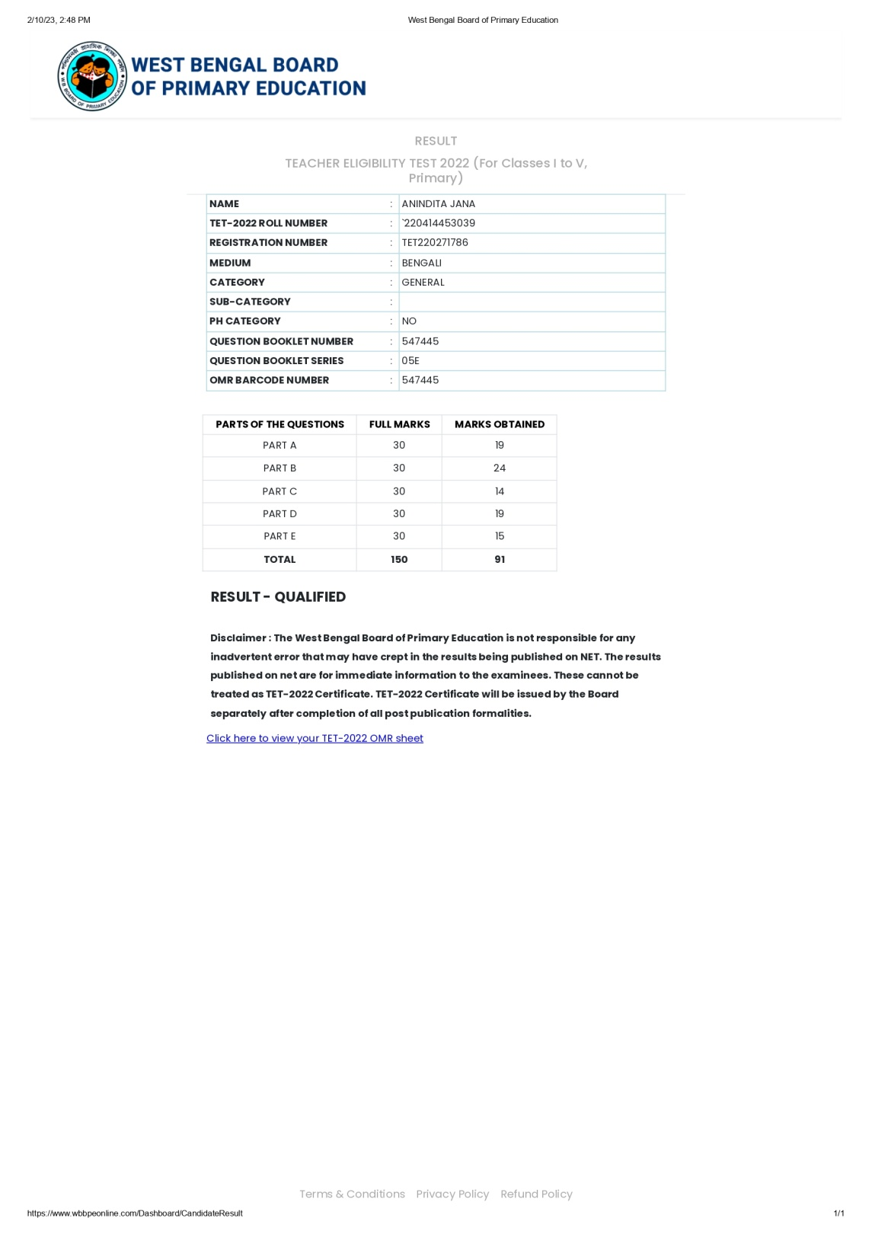

ANAL MISHRA  MSc: 2022  Reg No : TET220328955 | 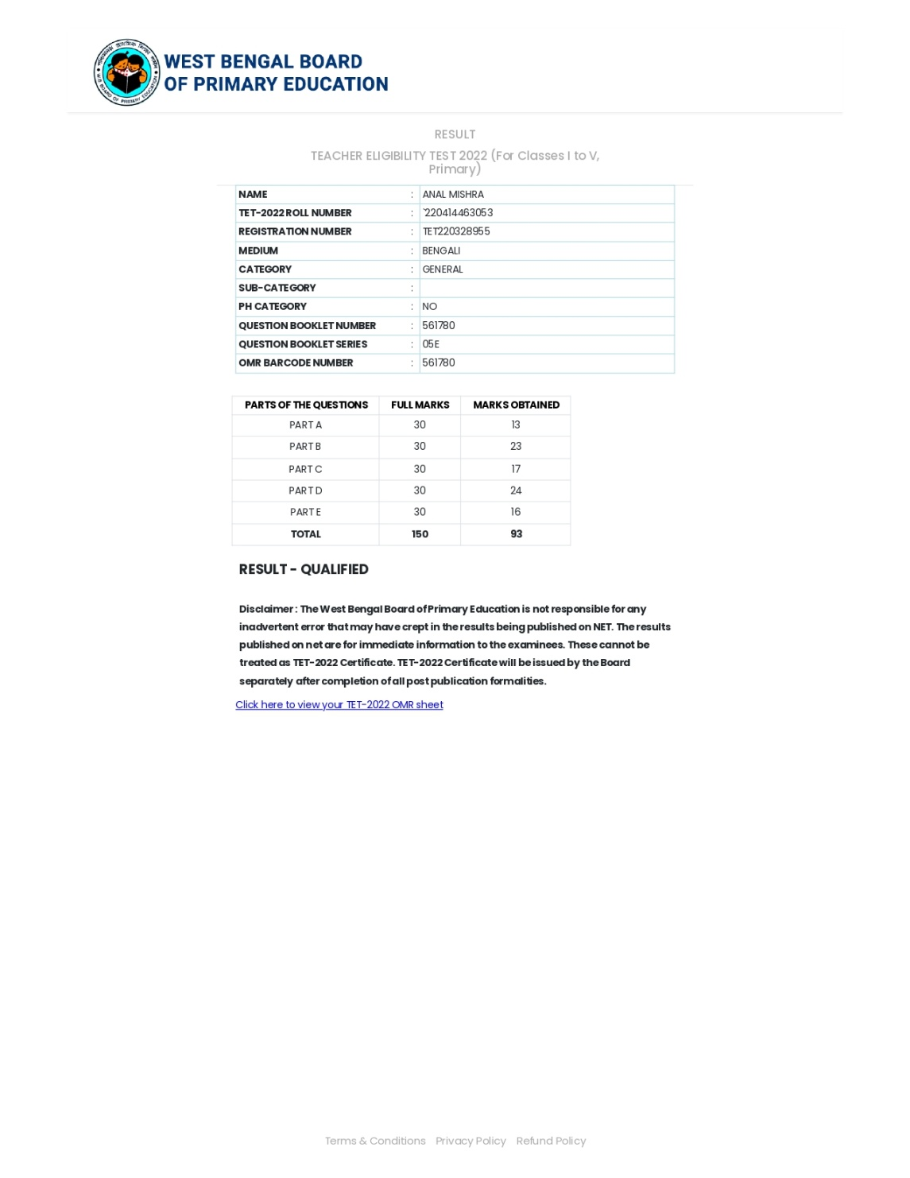

AMITAVA PATRA  BSc: 2019  Reg No : TET220024102 | 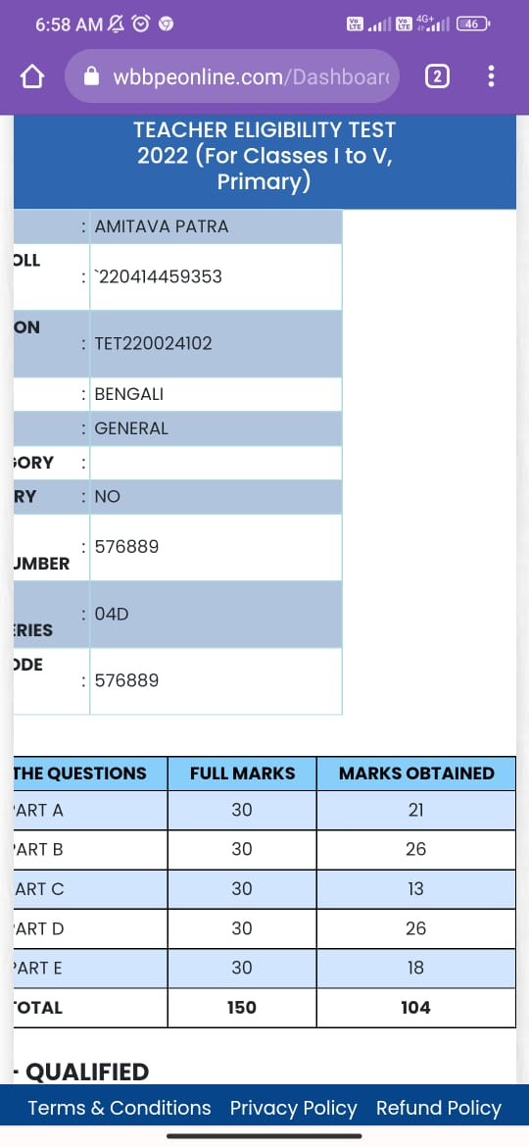

Ramkrishna Bar  MSc: 2020  Reg No:TET220321470 | 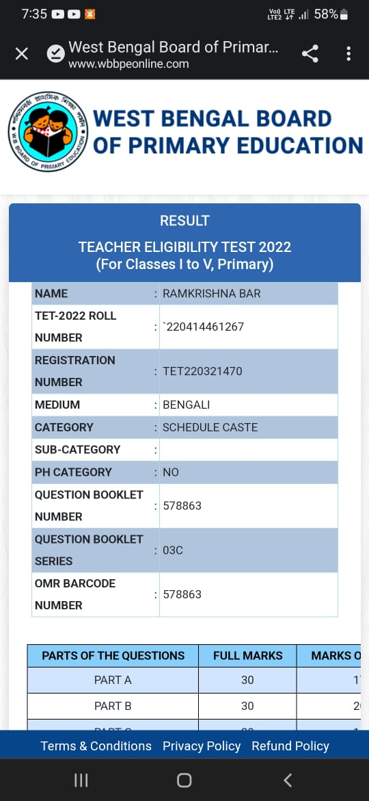

Ipsita Mishra  MSc  Reg No:220593842 | 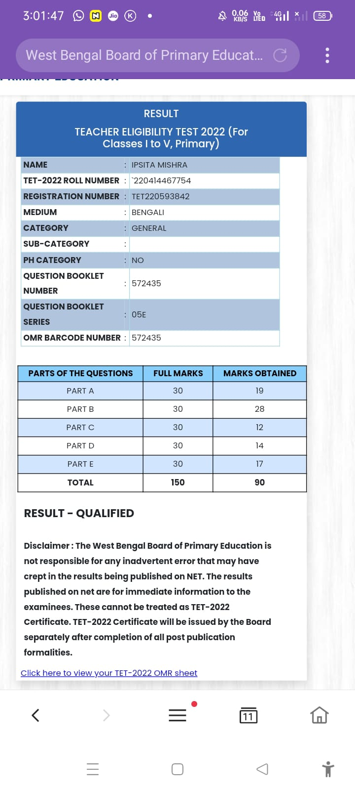

Parag Mondal  BSc:2020  Reg No:220088872 | 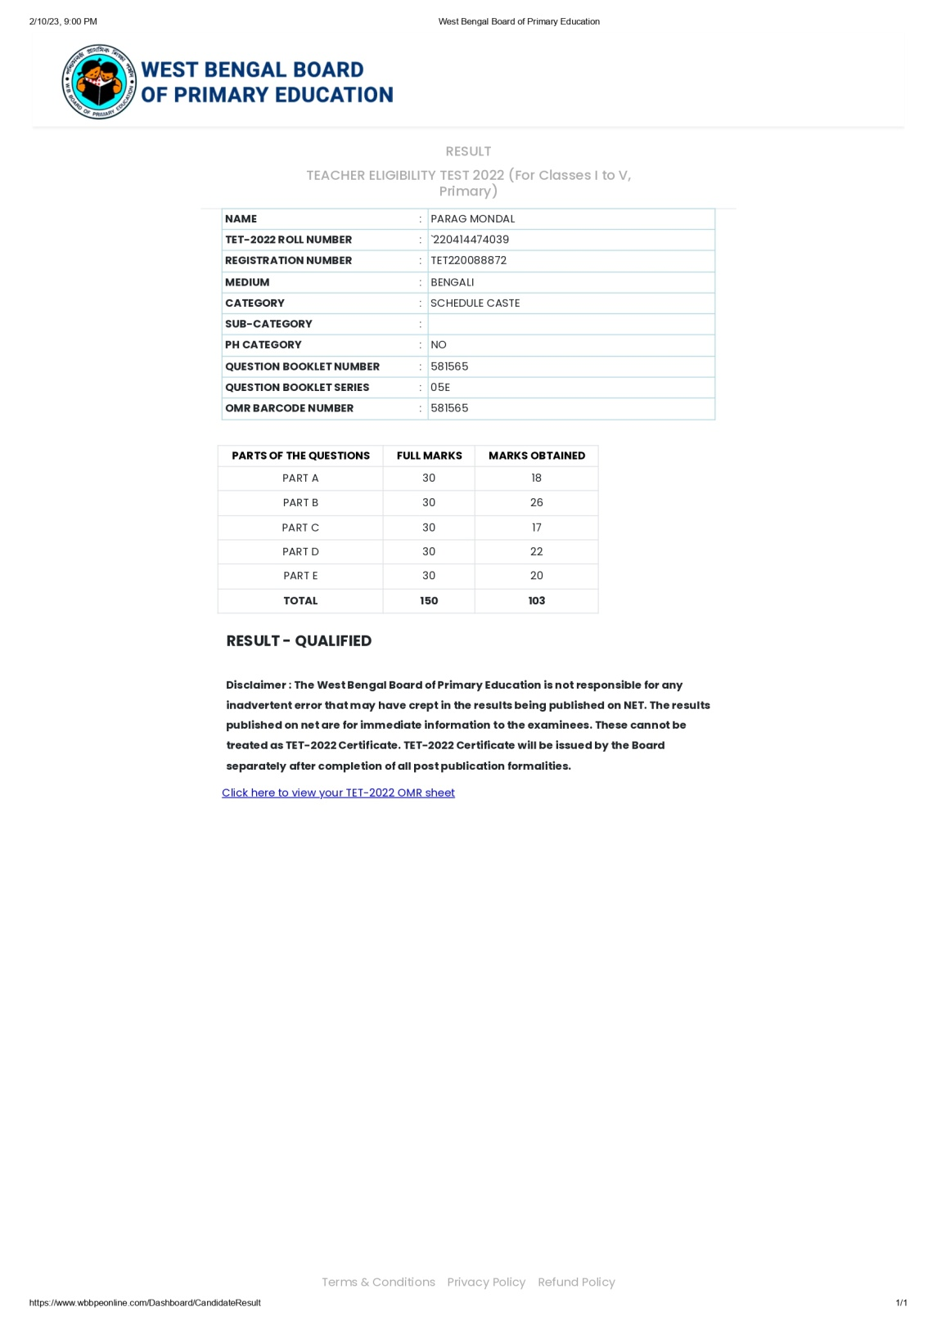

Ramkrishna BAR  MSc:2020  Reg No:24063865 | 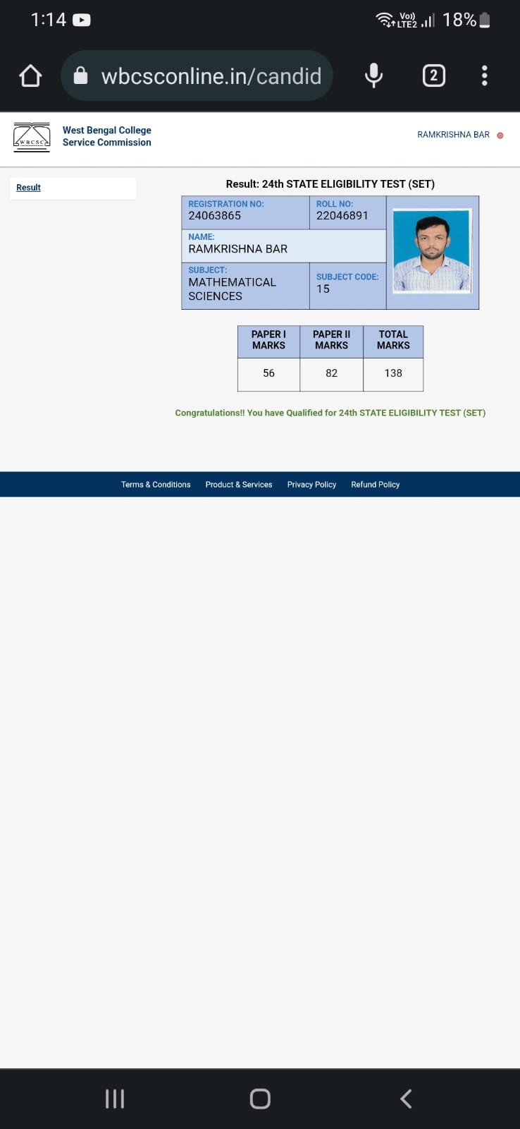

Gopal Das  MSc:2021  Reg No:40003260952 | 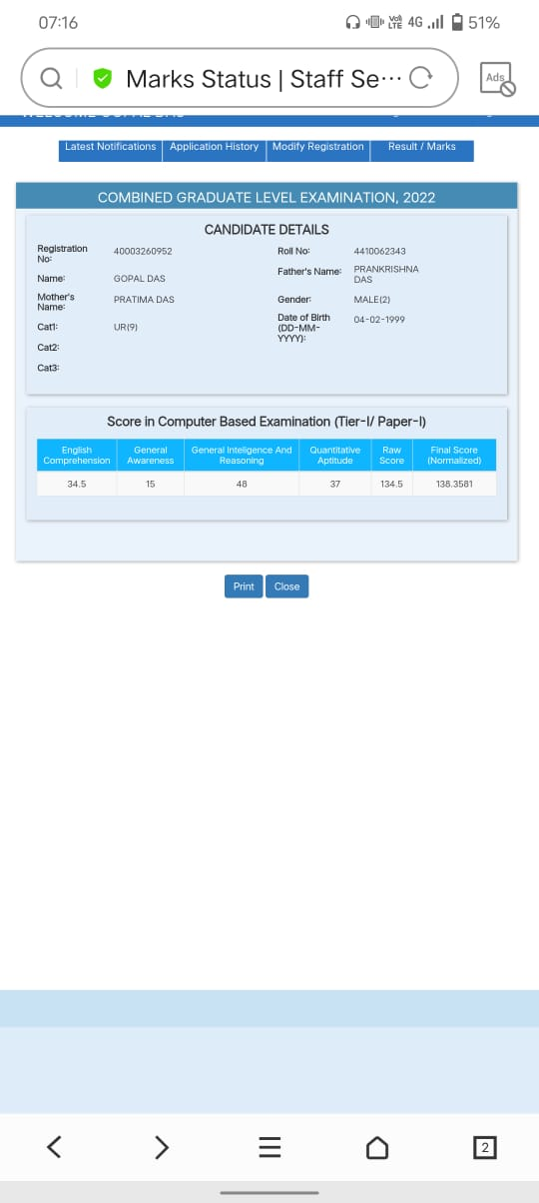

Chandan Giri  MSc:2021  Roll No:220230901150006 | 